3D City Database for CityGML

3D City Database Version 2.0.2 to 2.1.0
Importer/Exporter Version 1.3.0 to 1.6.0

Addendum to the
3D City Database Documentation Version 2.0.1
12 September 2013

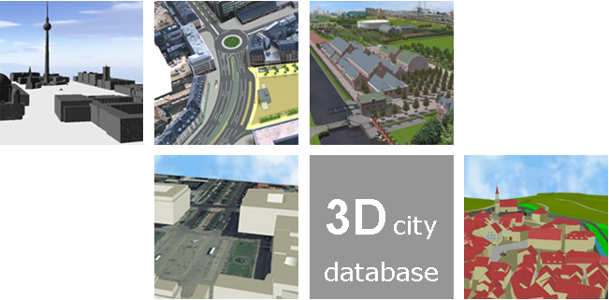

Participants in development
Name | Institution | Email
Thomas H. Kolbe  Zhihang Yao | Faculty of Civil, Geo and Environmental Engineering, Technische Universität München | thomas.kolbe@tum.de  zhihang.yao@tum.de
Javier Herreruela | Institute for Geodesy and Geoinformation Science, Technische Universität Berlin | javier.herreruela@tu-berlin.de
Claus Nagel  Felix Kunde | virtualcitySYSTEMS GmbH, Berlin | cnagel@virtualcitysystems.de  fkunde@virtualcitysystems.de
Philipp Willkomm  György Hudra | M.O.S.S. Computer Grafik Systeme GmbH, Taufkirchen, Germany | pwillkomm@moss.de  ghudra@moss.de

Content
1 Disclaimer 5
2 Overview 7
3 Changes in 3D City Database contents 9
3.1 ENVELOPE in CITYOBJECT Table 9
4 New Features 11
4.1 Graphical Bounding Box Choice Window 11
4.2 Plugin API 18
4.3 KML/COLLADA Export 20
4.3.1 Main parameters of the KML/COLLADA export 23
4.3.2 Preferences 28
4.3.2.1 General Preferences 28
4.3.2.2 Rendering Preferences 31
4.3.2.3 Information Balloon Preferences 35
4.3.2.4 Altitude/Terrain Preferences 43
4.3.3 Batch mode 48
4.3.4 Loading exported models in Google Earth 48
4.3.5 General setting recommendations 49
4.4 Support for Coordinate Reference Systems (CRS) 51
4.4.1 General information 51
4.4.2 Definition of the CRS for a 3D City Database instance 51
4.4.3 Management of user-defined CRSs 52
4.4.4 Usage of user-defined CRSs 55
4.4.5 Support for 3D CRS 57
4.4.6 Support for Point and Line Geometries of GenericCityObjects 59
4.5 CityGML Import Enhancements 61
4.5.1 Address storage 61
4.5.2 Affine Coordinate Transformation 63
4.5.3 Indexes 66
4.5.4 XML Validation 66
4.6 CityGML Export Enhancements 68
4.6.1 Coordinate Transformation 68
4.6.2 CityGML version 70
4.6.3 Address data reconstruction 70
4.6.4 Unique texture filenames 73
4.6.5 Tiling 74
4.7 Rework and Redesign of the Matching/Merging Tool 77
4.8 Extensions to the Database tab and preferences 80
4.9 Proxy support in preferences 86
4.10 New PL/SQL functionality 88
4.10.1 PL/SQL package GEODB_DELETE 88
4.10.2 Creating Read-Only Users 91
4.11 Test data and template files 93
5 Requirements 94
6 Upgrade from previous versions of the 3D City Database 96
7 Changelog 102
7.1 Changelog for the 3D City Database 102
7.2 Changelog for the Importer/Exporter 103
8 References 107

Disclaimer
The 3D City Database and the Importer/Exporter developed by the Institute for Geodesy and Geoinformation Science (IGG) at the Technische Universität Berlin is free software under the GNU Lesser General Public License Version 3.0. See the file LICENSE shipped together with the software for more details. For a copy of the GNU Lesser General Public License see the files COPYING and COPYING.LESSER or visit http://www.gnu.org/licenses/.
THE SOFTWARE IS PROVIDED BY IGG "AS IS" AND "WITH ALL FAULTS." IGG MAKES NO REPRESENTATIONS OR WARRANTIES OF ANY KIND CONCERNING THE QUALITY, SAFETY OR SUITABILITY OF THE SOFTWARE, EITHER EXPRESSED OR IMPLIED, INCLUDING WITHOUT LIMITATION ANY IMPLIED WARRANTIES OF MERCHANTABILITY, FITNESS FOR A PARTICULAR PURPOSE, OR NON-INFRINGEMENT.
IGG MAKES NO REPRESENTATIONS OR WARRANTIES AS TO THE TRUTH, ACCURACY OR COMPLETENESS OF ANY STATEMENTS, INFORMATION OR MATERIALS CONCERNING THE SOFTWARE THAT IS CONTAINED ON AND WITHIN ANY OF THE WEBSITES OWNED AND OPERATED BY IGG.
IN NO EVENT WILL IGG BE LIABLE FOR ANY INDIRECT, PUNITIVE, SPECIAL, INCIDENTAL OR CONSEQUENTIAL DAMAGES HOWEVER THEY MAY ARISE AND EVEN IF IGG HAVE BEEN PREVIOUSLY ADVISED OF THE POSSIBILITY OF SUCH DAMAGES.

Overview
Welcome to the release of the 3D City Database version 2.1.0 and the Importer/Exporter version 1.6.0. This document is an addendum to the previous documentation of the 3D City Database version 2.0.1 (cf. [1]) and replaces all previous addenda of the Importer/Exporter. Corrections and enhancements documented for those releases are also included in this guide and are explicitly labeled by markers on the left margin stating the version they were introduced with. The most recent changes brought by this release 1.6.0 are extra highlighted with a light blue background. For a full overview of the 3D City Database and the Importer/Exporter please also refer to the version 2.0.1 documentation (shipped with the distribution package of this release as well). This is a minor release of the 3D City Database and the Importer/Exporter. The next major release offering full support of the OGC CityGML 2.0.0 standard is scheduled for the end of 2013.
Version 2.1.0 of the 3D City Database complements the GEODB_DELETE package with low-level database procedures allowing for the deletion of all city objects as well as their geometries and appearances. Previous releases were restricted to the removal of building features and their components only. Version 1.6.0 of the Importer/Exporter provides performance improvements and bug fixes.
The 3D City Database version 2.1.0 is not a mandatory dependency of the Importer/Exporter version 1.6.0 which thus can still be used together with the previous version 2.0.6 of the database. Nevertheless, existing 3D City Database instances of version 2.0.5 or below have to be upgraded to version 2.0.6 / 2.1.0 in order to make use of the new features and improvements. An upgrade script is shipped with this release. Please refer to chapter 6 for the documentation of the upgrade procedure. If the 3D City Database instance is already running version 2.0.6, an upgrade to version 2.1.0 is only required to benefit from the new DELETE procedures.
Since release 1.4.0 (3D City Database 2.0.6) both the Importer/Exporter and the 3DCityDB are no longer constrained to an Oracle Spatial installation but can alternatively work on top of a PostgreSQL/PostGIS database. This is realized in the form of two separate software packages, each of them specifically adapted for the database type they are intended to work with (3DCityDB and Importer/Exporter for Oracle or 3DCityDB and Importer/Exporter for PostgreSQL/PostGIS). The contents of these packages are not interchangeable, that is, the 3DCityDB scripts for Oracle must be executed on Oracle Spatial, the 3DCityDB scripts for PostgreSQL/PostGIS on a PostgreSQL/PostGIS instance; the same applies for the Importer/Exporter versions. Plugins (see 4.2) must also adhere to this principle. A unified version of the Importer/Exporter supporting both spatial database systems will be addressed in the next major release of the Importer/Exporter (scheduled for the end of 2013).
The functionality of both 3DCityDB and Importer/Exporter versions (Oracle or PostgreSQL/PostGIS) is almost identical (the main exception being the history/workspace management only supported by Oracle so far). This addendum and the version 2.0.1 documentation are therefore valid for both of them. PostgreSQL/PostGIS specific details as well as some information about the software-porting process itself are collected and explained in the extra documentation delivered with the PostgreSQL/PostGIS distribution package. Further information, software downloads, ready-to-use demos, links to the source code repository, and much more can be found at the official website of the 3D City Database at http://www.3dcitydb.net.
Development efforts of the Importer/Exporter tool have been partially funded by the project Digitaler Gestaltplan Potsdam carried out in 2010/2011 within the European Regional Development Fund (ERDF) framework. Partners in this project were the City of Potsdam (Germany) as well as the company virtualcitySYSTEMS GmbH (Berlin, Germany) who also financially supported the development of the 3D City Database and the Importer/Exporter tool beyond this project. Previous releases were additionally supported by the Berlin Partner GmbH (Berlin, Germany) and the Berliner Senatsverwaltung für Wirtschaft, Technologie und Frauen (Berlin, Germany). In 2013, the company M.O.S.S. Computer Grafik Systeme GmbH (Taufkirchen, Germany) joined the 3D City Database project as active partner in development.
We thank all our partners for their kind support and for their provision of demonstration datasets.

Changes in 3D City Database contents

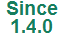
ENVELOPE in CITYOBJECT Table
Due to compatibility issues with Oracle 11g versions, a small but significant adaption was made on the contents of the table CITYOBJECT. It affects how the BoundingBox (column ENVELOPE) is stored. The BoundingBox is realized by an Oracle data type SDO_GEOMETRY, but from version 2.0.6 on this is no longer specified as a rectangle type (SDO_INTERPRETATION = 3) using two opposite points, but as a simple 3D polygon (SDO_GTYPE = 3003, SDO_ETYPE = 1003, SDO_INTERPRETATION = 1) using five points, that join the minimum and maximum x, y and z coordinates of the BoundingBox and define it completely. For backwards compatibility reasons (to Oracle 10g) the envelope cannot be stored as a volume.
This means, with a practical example, the envelope of an object in version 2.0.5 of the 3D City Database was stored as follows:
MDSYS.SDO_GEOMETRY(3003,32632,NULL,MDSYS.SDO_ELEM_INFO_ARRAY(1,1003,3),MDSYS.SDO_ORDINATE_ARRAY(602158.6484,6102435.8133,14.22618,602167.1064,6102442.3621,18.63145))
Since version 2.0.6, the envelope of the same object will be stored as:
MDSYS.SDO_GEOMETRY(3003,32632,NULL,MDSYS.SDO_ELEM_INFO_ARRAY(1,1003,1),MDSYS.SDO_ORDINATE_ARRAY(602158.6484,6102435.8133,14.22618,602167.1064,6102435.8133,14.22618,602167.1064,6102442.3621,18.63145,602158.6484,6102442.3621,18.63145,602158.6484,6102435.8133,14.22618))
Please note that the maximum and minimum coordinate values remain unchanged, but now the connection between them has become explicit. This is a consequence of changing the SDO_INTERPRETATION value from 3 to 1.
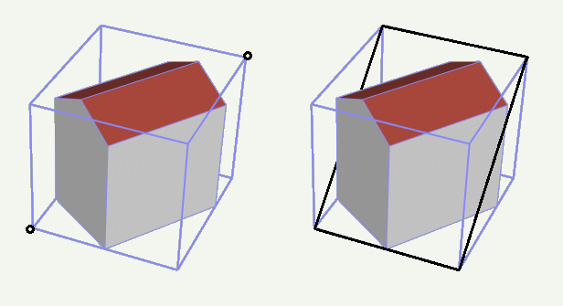
Fig. 1: CityObject envelope storage in 2.0.5 (left: as a 3D rectangle specified by the two black points with minimum and maximum coordinate values respectively) and in 2.0.6 (right: black polygon)
This new definition of how CityObject envelopes must be stored replaces the old one in 2.3.2.1 Core Model from the documentation of the 3D City Database Version 2.0.1 (cf. [1]).
This change is required to guarantee a flawless working of spatial queries under Oracle 11g, like for CityGML or KML/COLLADA exports when applying a spatial BoundingBox filter. Using the 3D City Database 2.0.5 package on Oracle 11g installations is strongly discouraged since this can lead to repeated spatial query failures (with the Importer/Exporter or other tools).
The reason why the envelope is not simply stored as a volume results from the intended backwards compatibility to Oracle 10g, which does not support 3D volumetric geometries (only 3D polygons).
The upgrade script to version 2.1.0 includes the adaption of all CityObject envelope values in all workspaces automatically without requiring any interaction from the user on this topic.

New Features

Graphical Bounding Box Choice Window
A GUI component allowing for a better overview of the chosen BoundingBox (at the time of choosing and afterwards) was added in release 1.4.0. The enhanced BoundingBox component is present at the three main tabs: Import, Export, and KML/COLLADA Export and works identically at all three.
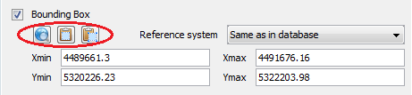
Fig. 2: Enhanced BoundingBox component
The first noticeable difference to previous Importer/Exporter releases are the new icon buttons on the top left corner whose functionality (also explained by a tooltip when the mouse is hovering over) is from left to right: open map window to select a bounding box, copy bounding box to clipboard and paste bounding box from clipboard.
When clicking on the open map window to select a bounding box icon button a new window pops up showing a map of the selected bounding box in case the Xmin, Xmax, Ymin, Ymax entries contain valid values or a world map with no selected area in case these entries are empty. All map contents are provided by the OpenStreetMap service (no usage limits, internet connection / network proxies, see chapter 4.9, must be properly configured).
The map window can also be opened from the main menu under the View element. In that case the map window will show the area and values that were last used and will lack of the Apply button on the upper right corner. Copying and pasting from and to the clipboard will continue working though.
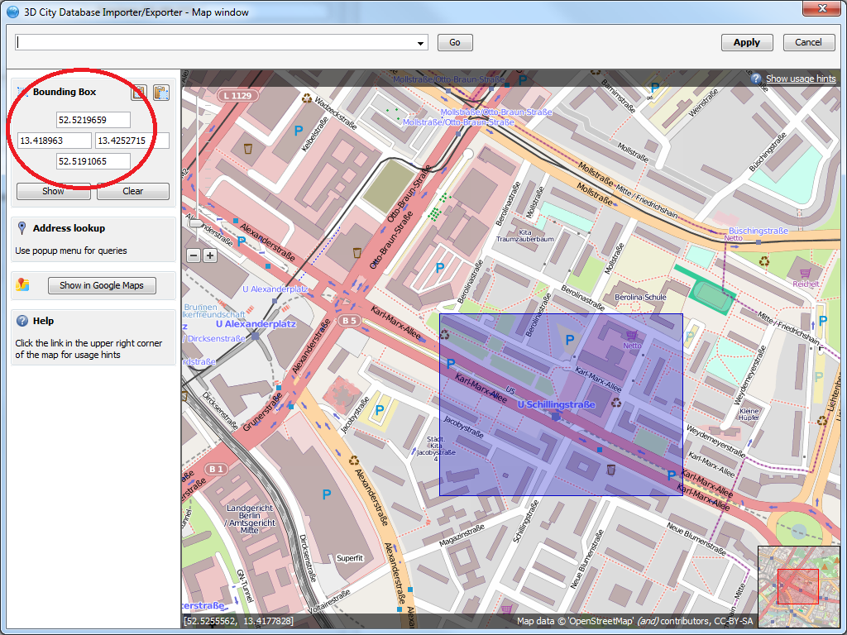
Fig. 3: Selected bounding box displayed graphically; coordinates are automatically calculated and transformed.
Regardless of the reference system used in the original bounding box, coordinates in the map window will always be shown in WGS84. This is required by the OpenStreetMap service. In case the given bounding box is not defined in this reference system a conversion must take place. A connection to a database supporting the given reference system must be established in order to convert the coordinates. If this is not yet the case a pop-up dialog will ask you for permission.
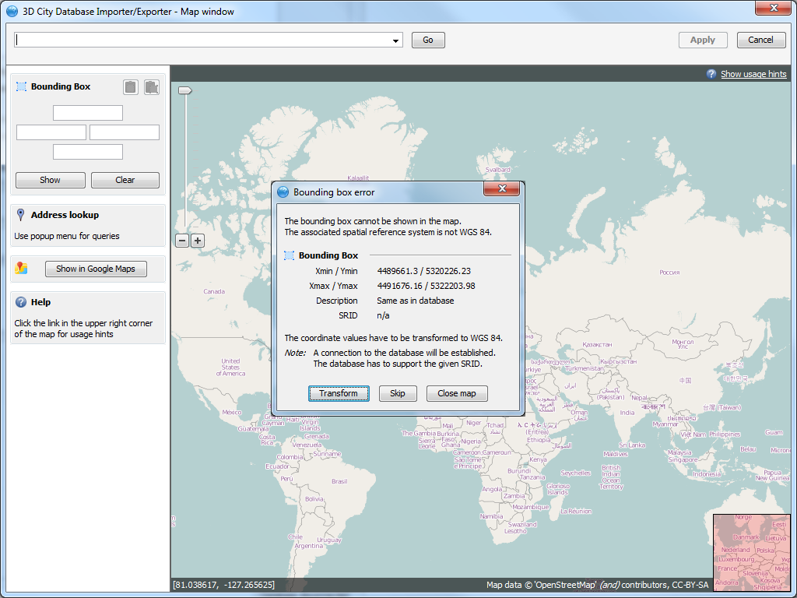
Fig. 4: Asking for permission before connecting to a DB for coordinate conversion
Coordinates can be retrieved and set any time by means of the copy and paste graphic buttons available on the map window and in the BoundingBox component present at the three main tabs: Import, Export and KML/COLLADA Export. Exchange of these values always happens through the clipboard.
The Apply button on the upper right corner of the map window is a shortcut for copying the coordinate values to the clipboard and pasting them in the bounding box fields of the calling tab. Furthermore, coordinate values can now be easily copied from one tab to another by simply clicking on the Copy button in one of them, say Import tab, with filled bounding box values, changing to another, say KML/COLLADA Export tab and clicking on the Paste button there. Previously existing values in the bounding box fields of the KML/COLLADA Export tab (if any) will be overwritten.
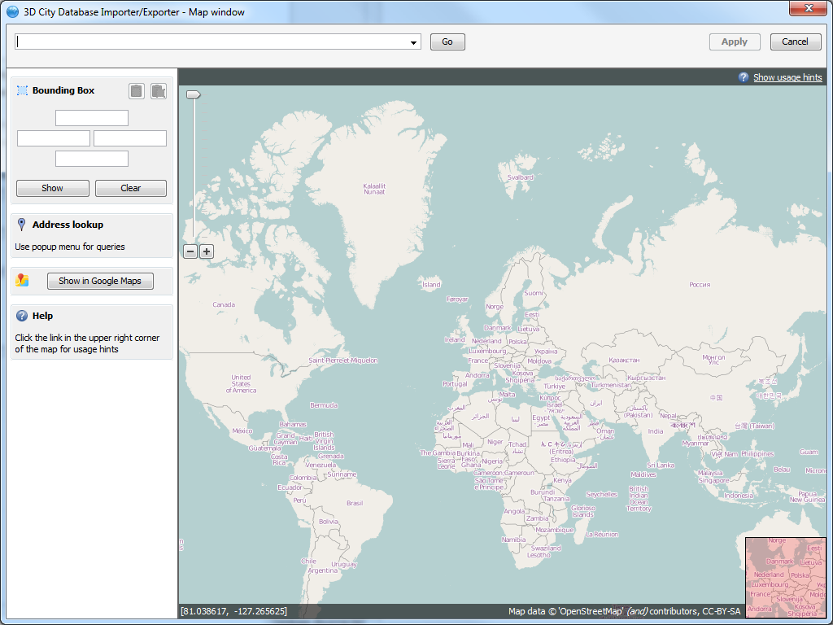
Fig. 5: World map is shown when no bounding box coordinate values are set
In case no bounding box is selected you can navigate to the area of interest or, more comfortably, make use of the of the geocoding service included in the map window. Simply type any address in the top left field and click on the Go button, you will be automatically redirected to the first matching area containing this address.
The geocoding service, based on a Google API, is limited to 2500 requests per day and IP address.
The currently shown map extent can also be opened in Google Maps for further inspection or comparison by clicking on the Show in Google Maps button. This will open a new web browser window showing the corresponding map view in Google Maps.
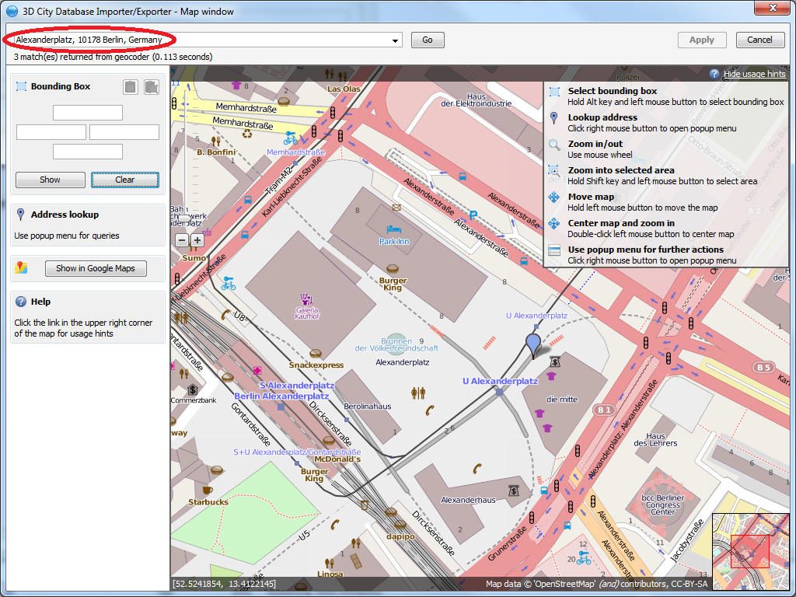
Fig. 6: Usage of the geocoding service
Once you are near the area of interest you can slide with the mouse (by holding the left button down) to the exact position you are interested in. The mouse wheel is used for zooming in and out of the map. A comprehensive list of usage hints is shown (and hidden) by clicking on the link at the upper right map corner. These hints are:
- Select bounding box: hold alt key and left mouse button to select bounding box. By dragging the mouse while holding down the alt key and left mouse button the bounding box is interactively displayed in a light magenta color over the map contents. Once the left mouse button is released, the coordinates of the bounding box are automatically filled in the fields left of the map. The procedure can be repeated any number of times until the desired bounding box is selected. By clicking on the Apply button on the upper right corner of the window, which has now become active, the window will be closed and the bounding box values transferred to the clipboard and to the calling tab in the main Importer/Exporter tool window.
- Lookup address: click right mouse button to open popup menu. When the right mouse button is clicked on a point of the map surface a context menu appears offering several options. The last of them being Lookup address here. If this option is chosen, the point will be highlighted by a green arrow and its address will be displayed on the column left of the map (see Fig. 7). This information is supplied by a reverse geocoding service, also based on a Google API and also limited to 2500 requests per day and IP address.
- Zoom in/out: use mouse wheel.
- Zoom into selected area: hold shift key and left mouse button to select area. Similarly to Select bounding box, by dragging the mouse while holding down the shift key and left mouse button a bounding box is interactively displayed in a light grey color over the map contents. Once the left mouse button is released, the selected area will be zoom in and fill the map window completely. This feature can be used to recursively come closer to a zone whose coordinates are not precisely known but its topological properties are. When the maximum zoom level is reached this action has no further effect.
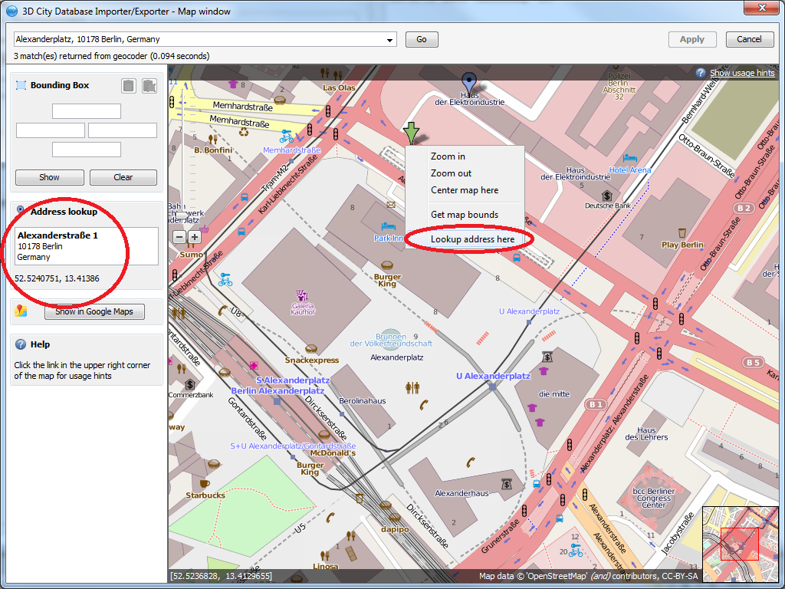
Fig. 7: Reverse geocoding in the graphical bounding box choice window
- Move map: hold left mouse button to move the map.
- Center map and zoom in: double click left mouse button to center map. Double clicking on any point of the map surface will increase the current zoom level one step and set the exact clicked on point to be the center of the newly displayed area. When the maximum zoom level is reached only the new centering will take place.
- Use popup menu for further actions: click right mouse button to open popup menu. The context menu triggered by a right mouse click offers additional access to some functions, like Zoom in, Zoom out and Center map here for the case the mouse has no wheel or does not support double clicking. Plus the options Get map bounds, equivalent to selecting all visible content in the map window as a bounding box, which will be accordingly shown in light magenta color and have its coordinates automatically transferred to the fields left of the map, and Lookup address here, that was previously explained.

Plugin API
Functionalities in the Importer/Exporter can be extended in a modular way with the installation of plugins that add specific abilities for interacting with the 3D City Database or external data. A plugin may provide a new tab or a new menu bar extension possibly accompanied by a preferences extension and/or a project configuration file extension. Plugins are self-contained and each of them can be added separately to the main program. No interdependence among plugins can exist (plugins cannot extend the functionality of other plugins).
The plugin API can be added to the Importer/Exporter path at installation time if the user decides to do so (not selected by default). It will be copied to its own plugin-api subfolder containing the 3dcitydb-impexp-plugin-api.jar file itself, a readme file, license information and javadoc documentation. A more extensive plugin API guide will be offered on the www.3dcitydb.net site in the near future.
Currently, two plugins are already available: Matching/Merging (formerly integral part of the Importer/Exporter up to version 1.3.0) and Spreadsheet Generator (a new development that allows general purpose exports of 3D City Database contents in table/spreadsheet suitable form, either to a local .csv file with variable formatting or directly to an online spreadsheet hosted in the Google Docs cloud). The source code of both plugins is freely available to be reviewed and studied as a sample for the realization of future plugins.
Plugin installation is simple. Just download the plugin .zip file, unzip it and add the plugin folder as is into the plugins subfolder of the Importer/Exporter installation path. Start the Importer/Exporter again. Plugins will be automatically detected and started with the application.
Note: Since release 1.4.0 (3D City Database 2.0.6) the Importer/Exporter and the 3DCityDB can alternatively work on top of a PostgreSQL/PostGIS database. This is realized in the form of two separate software packages, each of them specifically adapted for the database type they connect to. Plugins are also coded differently depending on the database vendor system they are intended to work with. A Plugin written for the Oracle version of the Importer/Exporter will not run when added to PostgreSQL/PostGIS version and vice versa.

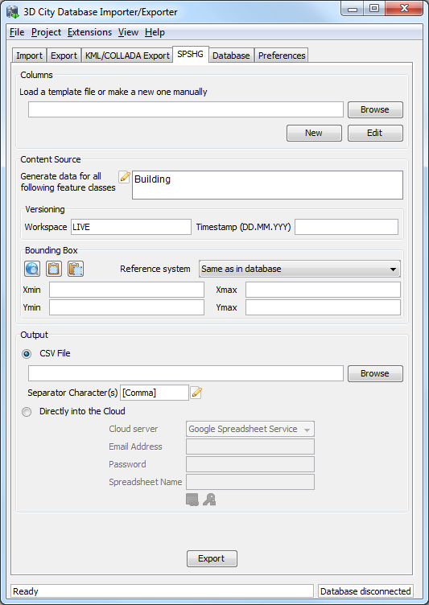
Fig. 8: Importer/Exporter started with the Spreadsheet Generator plugin installed

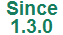
KML/COLLADA Export
One of the most outstanding features introduced with release 1.3.0 of the Importer/Export was the KML/COLLADA export capability. 3D City Database contents can be directly exported in KML and COLLADA formats for presentation, viewing, and visual inspection in a broad range of applications such as earth browsers like Google Earth, ArcGIS and ArcGIS Explorer. Built-in support for object highlighting and generic creation of KML information balloons facilitate the interactive exploration of your 3D city models. Since release 1.5.0, the export works for all CityGML top-level feature types like vegetation, transportation complex, etc.
Note: Starting with version 7 (and at least up to version 7.1.1.1888) Google Earth has changed the way transparent or semi-transparent surfaces are rendered. This is especially relevant for visualizations containing highlighting surfaces (explained in chapter 4.3.1). When viewing KML/COLLADA export results in Google Earth it is strongly recommended to use an older Google Earth 6 version or, from Google Earth 7 upwards switch to the OpenGL graphic mode for an optimal viewing experience. Changing the Graphic Mode can be achieved by clicking on Tools, Options entry, 3D View Tab.
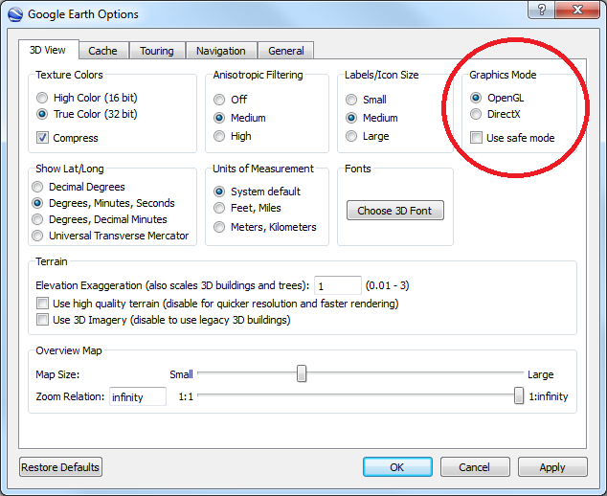
Fig. 9: Setting the Graphics Mode in Google Earth

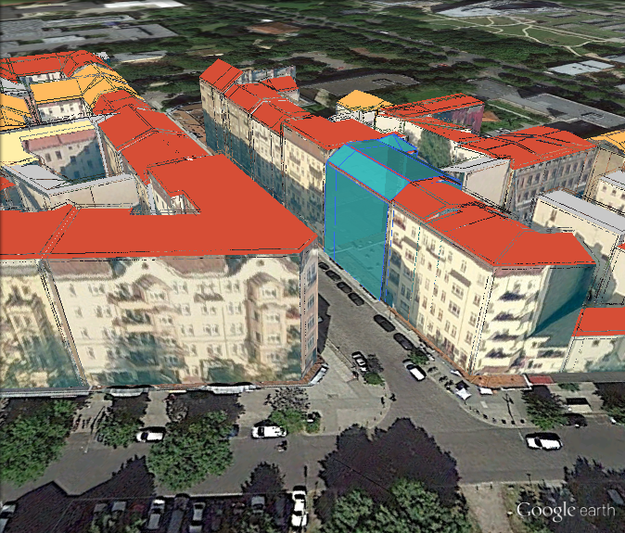
Fig. 10: KML/COLLADA export rendered with DirectX, highlighting surface borders are noticeable everywhere
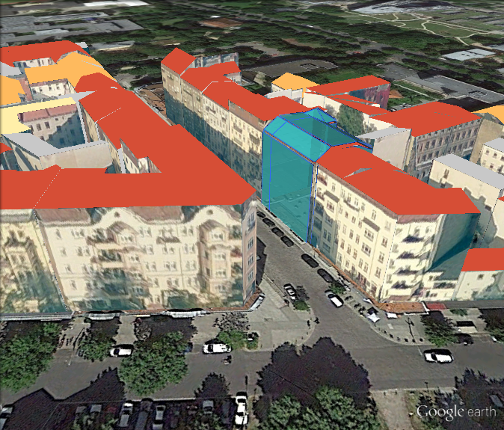
Fig. 11: The same scene rendered in OpenGL modus
The KML/COLLADA Export tab shown in Fig. 12 collects all parameters required for the export in a similar fashion as for a CityGML export. On the preferences tab a menu node called KML/COLLADA Export containing four subnodes – General, Rendering, Balloon, and Altitude/Terrain – makes customization of these exports possible.
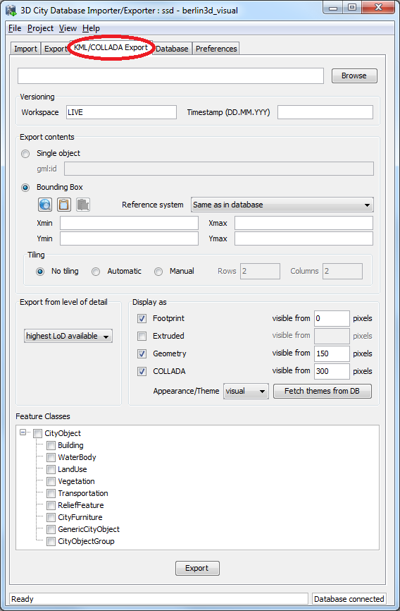
Fig. 12: The KML/COLLADA Export tab allowing for exporting KML/COLLADA models from the 3DCityDB.
Note: KML/COLLADA formatted exports come straight from the 3D City Database. No direct file transformation CityGML KML/COLLADA is provided. If a CityGML file shall be converted to KML/COLLADA, the CityGML content must be imported into the database first and then exported into the KML/COLLADA format.

Main parameters of the KML/COLLADA export
The input data fields on the KML/COLLADA Export tab are from the top down:
Output file selection
Type the filename directly into the text field or activate the file dialog provided by the operating system after pushing the Browse button.
Versioning
The Workspace Manager provided by Oracle is a comprehensive tool for version and history management. If the workspace management is activated, it works widely transparent for applications connected to the database. Workspace name and timestamp can be entered here in order to use a certain planning alternative and/or a given point in time as the basis for the KML/COLLADA exports.
If version management is disabled or the current state of the database should be exported, the default workspace name LIVE must be entered and the timestamp field must remain empty.
Export contents
These fields allow for specifying/selecting the objects of interest for the export. These can be single objects or whole areas delimited by a bounding box.
- Single object: Enter the GML IDs of the object(s) of interest. Multiple IDs have to be separated by commas.
- Bounding Box: Enter the coordinates of a bounding box defining the area of interest. Objects are exported if they are fully covered by the specified bounding box or if they intersect with its left or bottom borders. This strategy also applies to tiled exports (objects in a tile are only exported when fully covered by the tile's bounding box or intersecting with the tile's left or bottom borders). This is done in order to avoid exporting the same object twice when the object lies at the same time on more than one tile. The reference system used for defining the bounding box can be the same as the one used in the database or any other one supported by Oracle. With release 1.4.0, the possibility to add further user-defined reference systems was introduced (cf. chapter 4.4 for more details). New reference systems can be added to the Import/Export tool (preferences tab, node Database, subnode Reference systems) as long as they are supported by the Oracle DB server.
Tiling only applies to exports of areas defined by a bounding box. Tiled exports are used in order to load and unload parts of the exported model depending on their current visibility when viewed, for example, in Google Earth. Since the Earth Browser's responsiveness decreases greatly with single files larger than 10 Mb, tiled exports (with tile file sizes usually a lot smaller than that) are highly recommended. As mentioned above, only objects fully covered by the tile's bounding box or intersecting with the tile's left or bottom borders will be exported.
There are three tiling modes available for a KML/COLLADA export:
- no tiling: as the name implies, no tiling takes place. Just a single file is exported. This is only advisable when the resulting file is at most 10 Mb in size.
- automatic: the area enclosed by the bounding box will be exported in tiles having roughly the side length set on the preferences tab under the node KML/COLLADA Export, subnode Rendering (default value is 125m.). The amount of exported rows and columns will be calculated by dividing the length and width (in unit of meters) of the delimiting bounding box by the preferred tile side length and rounding up the result. For example: if the user wants to export a 1000m x 1100m bounding box with a preferred tile side length of 300m, 4x4 tiles will be generated since 1000/300 = 3.333 and 1100/300 = 3.666. This also implies: in case of automatic tiling it cannot be guaranteed that tiles will be perfectly square, but they will tend to.
- manual: the number of rows and columns can be freely set by the user. The area will be divided in equally spaced portions horizontally and vertically and the resulting tile sizes and forms will adapt to the values specified.
All these tiling modes can be combined with the (Preferences -> General) option “Each CityObject in an own region”, which for each object exported defines a region limited by its envelope coordinates. The single object regions may have different visibility settings to those of the tiles containing them, so it can be possible that while a tile as a whole is visible some objects inside are not because their own region visibility conditions are not yet matched.
Untiled exports (no tiling) and tiled exports of type automatic or manual will contain one main kml file, so-called master file, pointing to all export contents. In case of tiled exports each tile filename will be enhanced with the tile's row and column number as a suffix.
Export from level of detail
The Level of Detail as defined by the CityGML specification [2] which should be used as basis information for the KML/COLLADA export. For the same city object higher levels of detail usually contain many more geometries and these geometries are more complex than in lower levels. For instance, a building made of 40 polygons in LoD2 may consist of 3000 polygons in LoD3. This means LoD3 based exports are a lot more detailed than LoD2 based exports, but they also take longer to generate, are bigger in size and therefore load more slowly in the Earth browser.
A single constant LoD can be used as basis for all exports or it can be left to the importer/exporter tool to automatically determine which the highest LoD available for each cityobject is and then use it as the basis for the KML/COLLADA exports.
Display as
Determines what will be shown when visualizing the exported dataset in Google Earth.
- Footprint: objects are represented by their ground surface projected onto the earth surface. This is a pure KML export.
- Extruded: objects are represented as blocks models by extruding their footprint to their measured height (thematic CityGML attribute), which must be filled with a proper value in m. Pure KML export.
- Geometry: shows the detailed geometry of ground, wall, and roof surfaces of buildings and appearance information. It shows the different thematic surfaces by means of coloring them (textures are not supported by KML) according to the settings in the preferences tab, KML/COLLADA Export node, Rendering subnode. If not explicitly modeled, thematic surfaces will be inferred for LoD1 or LoD2 based exports following a trivial logic (surfaces touching the ground –that is, having a lowest z-coordinate- will be considered wall surfaces, all other will be considered roof surfaces), in LoD3 or LoD4 based exports surfaces not thematically modeled will be colored as wall surfaces. Pure KML export.
- COLLADA: shows the detailed geometry including support for textures. The Appearance/Theme combo box below allows choosing from all possible appearance themes (as defined in the CityGML specification [2]) available in the currently connected 3DCityDB. The list is workspace- and timestamp sensitive and will be filled on demand when clicking on the fetch button. Default value is none, which renders no textures at all and colors all surfaces in a neutral gray tone. Export consists of KML and COLLADA parts.
Depending on the level of detail chosen as basis some display form checkboxes will become enabled or disabled, depending on whether the level of detail offers enough information for this display form or not. Footprint can be exported from any CityGML LoD (0 to 4), whereas Extruded, Geometry, and COLLADA exports are possible from LoD1 upwards. In previous releases, the generation of COLLADA required at least LoD2. Exports will have their filename enhanced with a suffix specifying the selected display form. This applies for both tiled and untiled exports.
Since
1.6.0
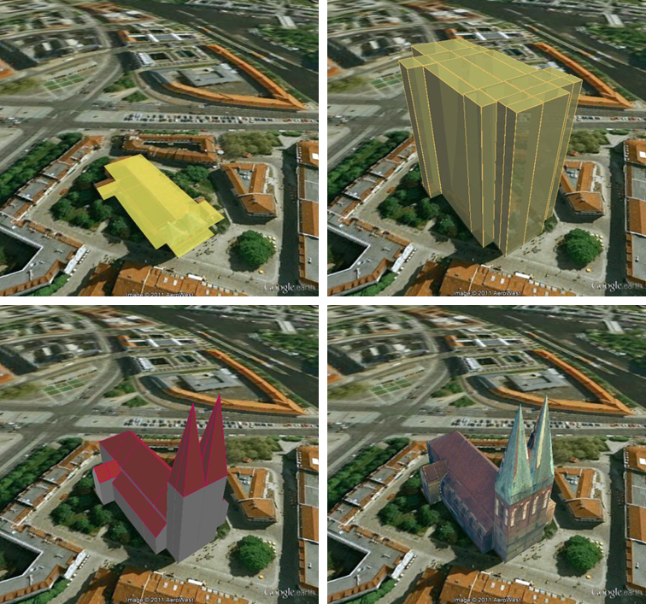
Fig. 13: The same building displayed as (top down and left to right) footprint, extruded, geometry, COLLADA.
With the visibility field next to each display form the user can control the KML element <minLodPixels>, see [3]: measurement in screen pixels that represents the minimum limit of the visibility range for a given <Region>. A <Region> is in the generated tiled exports equivalent to a tile. The <maxLodPixels> value is identical to the <minLodPixels> of the next visible display form, so that display forms are seamlessly switched when the viewer zooms in or out. The last visible display form has a <maxLodPixels> value of -1, that is, visible to infinite size. Visibility ranges can start at a value of 0 (they do not have to, though). Please note that the region size in pixels depends on the chosen tile size. Thus, if the tile size is reduced also the visibility ranges should be reduced. Increases in steps of a third of the tile side length are recommended. An example of a good combination for a tile size of about 250m x 250m could be: Footprint, visible from 50 pixels, Geometry, visible from 125 pixels, COLLADA, visible from 200 pixels. Some display forms, like Extruded in this example, can be skipped.
The visibility field only becomes enabled for bounding box exports; single building exports are always visible.
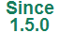
Feature Classes
Similar to CityGML imports and exports it is possible to select what top-level feature types shall be displayed in a KML/COLLADA export. Prior to version 1.5.0, this choice was exclusively limited to Buildings. With the newly introduced selection tree it is possible to pick each category individually and also leave single categories out, i.e.: export CityFurniture and WaterBodies only, or export everything but Buildings and so on. Between LoD1 and LoD4 all feature types are available. For LoD0 only those top-level feature types offering LoD0 geometry in the CityGML 1.0 schema (Waterbody, LandUse, Transportation and GenericCityObject) are selectable, whereas the rest of the feature class checkboxes will become automatically disabled.
Each of the top-level feature categories has its own Rendering and Balloon settings under Preferences. The most complex Rendering and Balloon settings for Buildings, will be explained as an example in the following sections. Settings for all other top-level features are either identical or simpler.
Note: Support for Relief features in KML/COLLADA exports is currently limited to the type TIN_RELIEF. Other Relief types are not rendered currently. Also, due to the usually wide-streched area of Relief features and the non-clipping nature of the BoundingBox filter it is recommended to export Relief features in a single step making use of the no tiling option and using an extensive enough BoundingBox.
As an alternative, the digital terrain model data can be divided in smaller ReliefComponents tailored to match the tiling settings of the desired export (their area contained in or equal to the resulting tiles). This requires altering the original data nevertheless and, as such, it must be done before the CityGML contents are imported into the database at all.

Preferences

General Preferences
Some common features of the exported files, especially those related to tiling options, can be set under the preferences tab, node KML/COLLADA Export, subnode General.
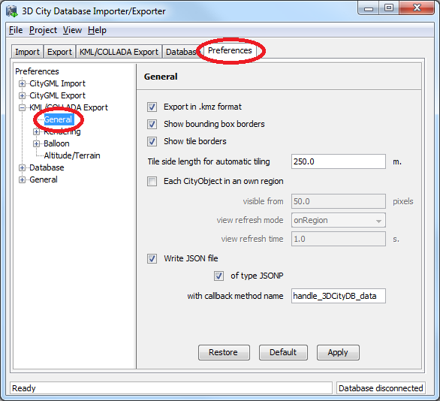
Fig. 14: General settings for the KML/COLLADA export.
Export in kmz format
Determines in which format single files and tiled exports should be written: kmz when selected, kml when not. Whatever format is chosen, the main file (so called master file, pointing to all others) will always be a kml file, all other files will comply with this setting.
Tests have shown shorter loading times (in Google Earth) for the kml format (as opposed to kmz) when loading from the local hard disk. The Earth Browser's stability also seems to improve when using the uncompressed format. On the other hand, when loading files from a server kmz reduces the amount of requests considerably, thus increasing performance. Kmz is also recommended for a better overview since kml exports may lead to a large number of directories and files.
Show bounding box borders
When exporting a region of interest via the bounding box option in the KML/COLLADA Export tab, this checkbox specifies whether the borders of the whole bounding box will be shown or not. The frame of the bounding box is four times thicker than the borders of any single tile in a tiled export.
Show tile borders
Specifies whether the borders of the single tiles in a tiled export will be shown or not.
Tile side length for automatic tiling
Applies only to automatically tiled exports and sets the approximate square size of the tiles. Since the Bounding Box settings in the KML/COLLADA Export tab are the determining factor for the area to be exported and have priority over this setting, the resulting tiles may not be perfectly square or have exactly the side length fed into this field.
Each CityObject in an own region
The visibility of the objects exported can be further fine-tuned by this option. While the visibility settings on the main KML/COLLADA Export tab apply to the whole area (no tiling) or to each tile (automatic, manual) being exported, this checkbox allows to individually define a KML <Region> for every single city object. The limits of the object’s region are those of the object’s CityGML Envelope.
Following the KML Specification [3], each KML <Region> is defined inside a KML <NetworkLink> and has an associated KML<Link> pointing to a file. This implies when this option is chosen a subfolder is created for each object exported, identified by the object’s gmlId. The object’s subfolder will contain any KML/COLLADA files needed for the visualization of the object in the Earth browser. This folder structure (which can contain a large number of subfolders) is required for the KML <Region> visibility mechanism to work.
When active, the parameters affecting the visibility of the object’s KML <Region> can be set through the following related fields.
The field visible from determines from which size on screen the object’s KML <Region> becomes visible, regardless of the visibility value of the containing tile, if any. Since this value is the same for every single object and they have all different envelope sizes a good average value should be chosen.
The field view refresh mode specifies how the KML <Link> corresponding to the KML <Region> is refreshed when the geographic view changes. May be one of the following:
- never - ignore changes in the geographic view.
- onRequest - refresh the content of the KML <Region> only when the user explicitly requests it.
- onStop - refresh the content of the KML <Region> n seconds after movement stops, where n is specified in the field view refresh time.
- onRegion - refresh the content of the KML <Region> when it becomes active.
As stated above, the field view refresh time specifies how many seconds after movement stops the content of the KML <Region> must be refreshed. This field is only active and its value is only applied when view refresh mode is onStop.
Write JSON file
After exporting some cityobjects in KML/COLLADA you may need to include them into websites or somehow embed them into HTML. When working with tiled exports referring to a specific object inside the KML/COLLADA files can become a hard task if the contents are loaded dynamically into the page. It is impossible to tell beforehand which tile contains which object. This problem can be solved by using a JSON file that is automatically generated when this checkbox is selected.
In the resulting JSON file each exported object is listed, identified by its gmlId acting as a key and some additional information is provided: the envelope coordinates in CRS WGS84 and the tile, identified by row and column, the object belongs to. For untiled exports the tile’s row and column values are constantly 0.
This JSON file has the same name as the so-called master file and is located in the same folder. Its contents can be used for indexed search of any object in the whole KML/COLLADA export.
JSON file example:
{
"BLDG_0003000b0013fe1f": {
"envelope": [13.411962, 52.51966, 13.41277, 52.520091],
"tile": [1, 1]},
[…]
"BLDG_00030009007f8007": {
"envelope": [13.406815, 52.51559, 13.40714, 52.51578],
"tile": [0, 0]}
}
Since version 1.5.0, the JSON file can automatically be turned into JSONP (JSON with padding) by means of adding a function call around the JSON contents. JSONP provides a method to request data from a server in a different domain, something typically forbidden by web browsers since it is considered a cross-site-scripting attack (XSS). Thanks to this minimal addition the JSON file contents can be more easily embedded into webpages or interpreted by web kits without breaking any rules. The function call name to be added to the original JSON contents is arbitrary and must only be entered in the callback method name field.

Rendering Preferences
Most aspects regarding the look of the KML/COLLADA exports when visualized in Google Earth can be customized under the preferences tab, node KML/COLLADA Export, subnode Rendering, sub-subnode Feature Class. For the sake of clarity only the Building Rendering settings (that happen to be the most complex) will be explained here. The content of the rendering preferences for all other CityGML top-level features is either identical or simpler.
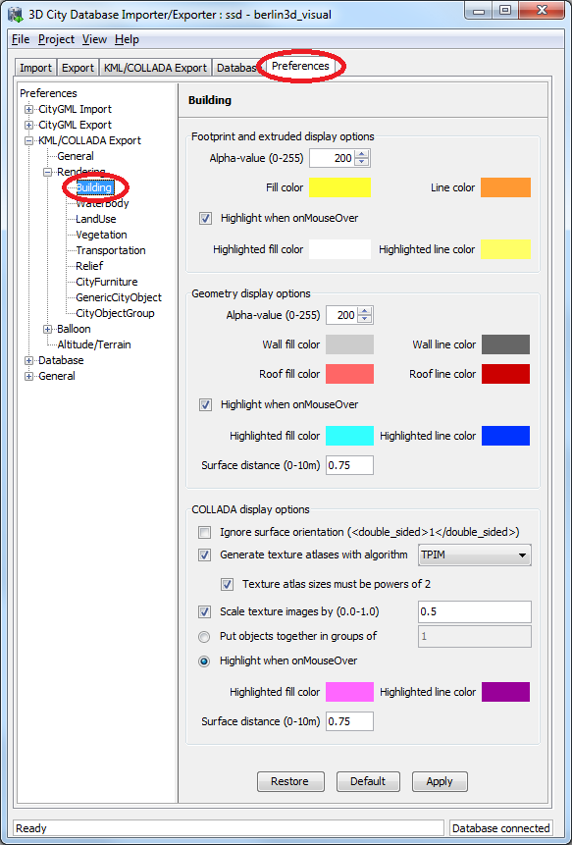
Fig. 15: Rendering settings for the KML/COLLADA Building export.

All settings in this menu are grouped according to the display form they relate to.
Footprint and extruded display options
In this section the fill and line colors can be selected. Additionally, it can be chosen whether the displayed objects should be highlighted when being run over with the mouse or not. Highlighting colors can only be set when the highlighting option is enabled. The alpha value affects the transparency of all colors equally: 0 results in transparent (invisible) colors, 255 in completely opaque ones. A click on any color box opens a color choice dialog.
Geometry display options
This parameter section distinguishes between roof and wall surfaces and allows the user to color them independently. The alpha value affects the transparency of all roof and wall surface colors in the same manner as in the footprint and extruded cases: 0 results in transparent (invisible) colors, 255 in completely opaque ones. A click on any color box opens a color choice dialog.
As previously stated: when not explicitly modeled, thematic surfaces will be inferred for LoD1 or LoD2 based exports following a trivial logic (surfaces touching the ground –that is, having a lowest z-coordinate- will be considered wall surfaces, all other will be considered roof surfaces), in LoD3 or LoD4 based exports surfaces not thematically modeled will be colored as wall surfaces.
The highlighting effect when running with the mouse over the exported objects can also be switched on and off. Since the highlighting mechanism relies internally on a switch of the alpha values on the highlighting surfaces, the alpha value set in this section does not apply to the highlighted style of geometry exports, only to their normal style. For a detailed explanation of the highlighting mechanism see the following section.
COLLADA display options
These parameters control the export of textured models. The first option addresses the fact that sometimes objects may contain wrongly oriented surfaces (points ordered clockwise instead of counter-clockwise) as a result of errors in some previous data gathering or conversion process. When rendered, wrongly oriented surfaces will only be textured on the inside and become transparent when viewed from the outside. Ignore surface orientation informs the viewer to disable back-face culling and render all polygons even if some are technically pointing away from the camera.
Note: This will result in lowered rendering performance. Correcting the surface orientation data is the recommended solution. This option only provides a quick fix for visualization purposes.
Surface textures can be stored in an image file each, or grouped into large canvases containing all images clustered together, so called texture atlases, that significantly increase loading speed. Grouping images in an atlas or not and the algorithm selected for the texture atlas construction (differing in generation speed and canvas efficiency) can be set here. Depending on the algorithm and size of the original textures an object can have one or more atlases, but atlases are not shared between separate objects.
The texture atlas algorithms address the problem of two dimensional image packing, also known as 'knapsack problem', in different ways (see [8] and [12]):
- BASIC: the most elementary one. Images are sorted according to decreasing height. Their total width when put next to each other is computed and the square root of this value is taken as the atlas width limit. Texture images are then added left to right following their decreasing heights. When the atlas width limit is reached a new row of images is started within the atlas.
- SLEA: Sleater's algorithm (see [11]). Consists of four steps: (1) all items of width greater than 1/2 are packed on top of one another in the bottom of the strip. Suppose h0 is the height of the resulting packing All subsequent packing will occur above h0. (2) Remaining items are ordered by non-increasing height. A level of items are packed (in non-increasing height order) from left to right along the line of height h0. (3) A vertical line is then drawn in the middle to cut the strip into two equal halves (note this line may cut an item that is packed partially in the right half). Draw two horizontal line segments of length one half, one across the left half (called the left baseline) and one across the right half (called the right baseline) as low as possible such that the two lines do not cross any item. (4) Choose the left or right baseline which is of a lower height and pack a level of items into the corresponding half of the strip until the next item is too wide. A new baseline is formed and Step (4) is repeated on the lower baseline until all items are packed.
- TPIM: touching perimeter (see [9] and [10]). Sorts images according to non-increasing area and orients them horizontally. One item is packed at a time. The first item packed is always placed in the bottom-left corner. Each following item is packed with its lower edge touching either the bottom of the atlas or the top edge of another item, and with its left edge touching either the left edge of the atlas or the right edge of another item. The choice of the packing position is done by evaluating a score, defined as the percentage of the item perimeter which touches the atlas borders and other items already packed. For each new item, the score is evaluated twice, for the two item orientations, and the highest value is selected.
- TPIM_WO_R: touching perimeter without rotation. Same as TPIM, but not allowing for rotation of the original images when packing. Score is evaluated only once since only one orientation is possible.
From all these algorithms BASIC is the fastest (shortest generation time), TPIM the most efficient (highest used area/total atlas size ratio).
Scaling texture images is another means of reducing file size and increasing loading speed. A scale factor of 0.2 to 0.5 often still offers a fairly good image quality while it has a major positive effect on these both issues. Default value is 1.0 (no scaling). This setting is independent from the atlas setting and both can be combined together. It is possible to generate atlases and then scale them to a smaller size for yet shorter loading times in Google Earth.
Buildings can be put together in groups into a single model/placemark. This can also speed up loading, however it can lead to conflicts with the digital terrain model (DTM) of the Earth browser, since buildings grouped together have coordinates relative to the first building on the group (taken as the origin), not to the Earth browser's DTM. Only the first building of the group is guaranteed to be correctly placed and grounded in the Earth browser. If the objects being grouped are too far apart this can result in buildings hovering over or sinking into the ground or cracks appearing between buildings that should go smoothly together.
Up to Google Earth 7, no highlighting of model placemarks loaded from a location other than Google Earth's own servers is supported natively (glowing blue on mouse over). Therefore a highlighting mechanism of its own was implemented in the KML/COLLADA exporter: highlighting is achieved by displaying a somewhat "exploded" version of the city object being highlighted around the original object itself. "Exploded" means all surfaces belonging to the object are moved outwards, displaced by a certain distance orthogonally to the original surface. This "exploded" highlighting surface is always present, but not always visible: when the mouse is not placed on any building (or rather, on the highlighting surface surrounding it closely) this "exploded" highlighting surface has a normal style with an alpha value of 1, invisible to the human eye. When the mouse is place on it, the style changes to highlighted, with an alpha value of 140 (hard-coded), becoming instantly visible, creating this model placemark highlighted feel.
The displacement distance for the exploded highlighting surfaces can be set here. Default value is 0.75m.
This highlighting mechanism has an important side effect: the model's polygons will be loaded and displayed twice (once for the representation itself, once for the highlighting), having a negative impact in the viewing performance of the Earth browser. The more complex the models are, the higher the impact is. This becomes particularly noticeable for models exported from a LoD3 basis upwards. The highlighting and grouping options are mutually exclusive.
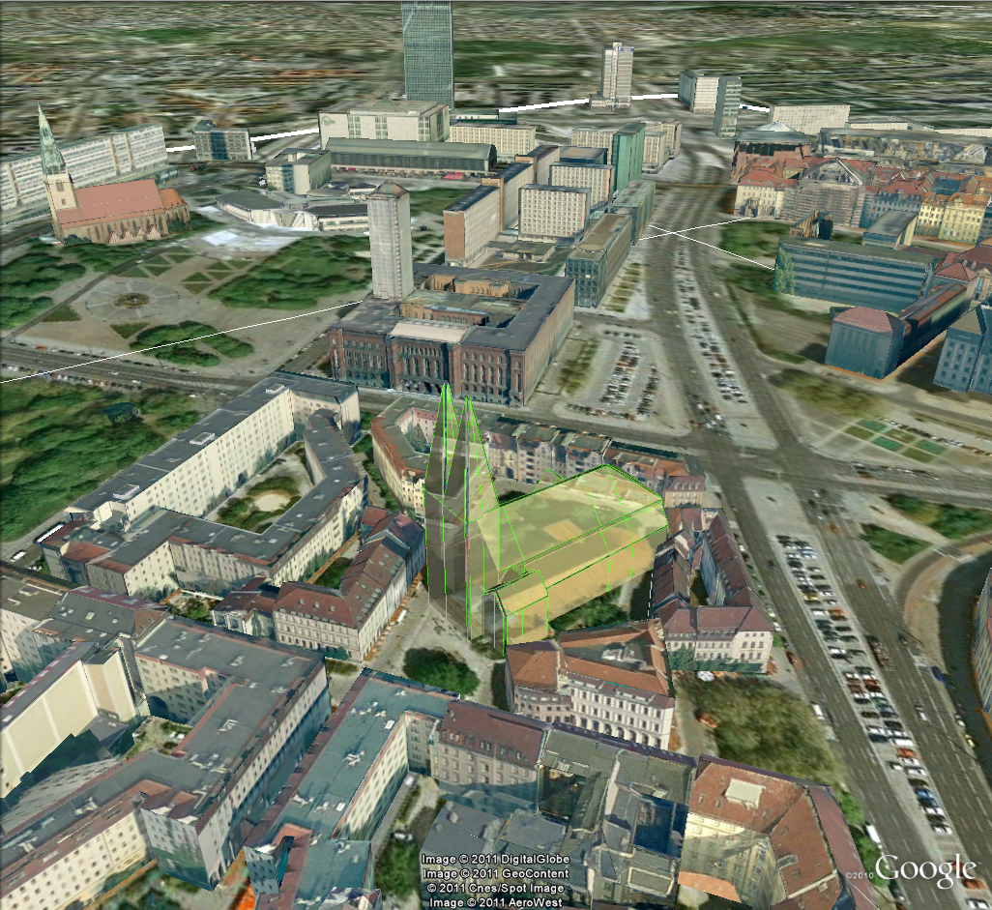
Fig. 16: Object exported in the COLLADA display form being highlighted on mouseOver.

Information Balloon Preferences
KML offers the possibility of enriching its placemark elements with information bubbles, so-called balloons, which pop up when the placemark is clicked on. This is supported by the Import/Export tool regardless of the display form the object is exported in.
Note: When exporting in the COLLADA display form it is recommended to enable the "highlighting on mouseOver" option, since model placemarks not coming from Google Earth servers are not directly clickable, but only through the sidebar. Highlighting geometries are, on the contrary, directly clickable wherever they are loaded from.
The contents of the balloon can be taken from a generic attribute called Balloon_Content associated individually to each city object in the 3DCityDB. They can also be uniform for all objects in an export by using an external HTML file as a template, or a combination of both: individually and uniformly set, the Balloon_Content attribute (individually) having priority over the external HTML template file (uniform). A few Balloon HTML template files can be found after software installation in the subfolder templates/balloons of the installation directory.
The balloons can be included in the doc.kml file generated at export, or they can be put into individual files (one for each object) written together into a "balloon" directory. This makes later adaption work easier if some post-processing (manual or not) is required. When balloon contents are put into a separate file for each exported object, access to local files and personal data must be granted in Google Earth (Tools Options General) for the balloons to show.
Balloon preferences can be set independently for each CityGML top-level feature type. That means every object can have its own individual template file (so that for instance, WaterBody balloons display a different background image as Vegetation balloons), and it is perfectly possible to have information bubbles for some object types while some others have none. The following example is set around Building balloons but it applies exactly the same for all feature classes.
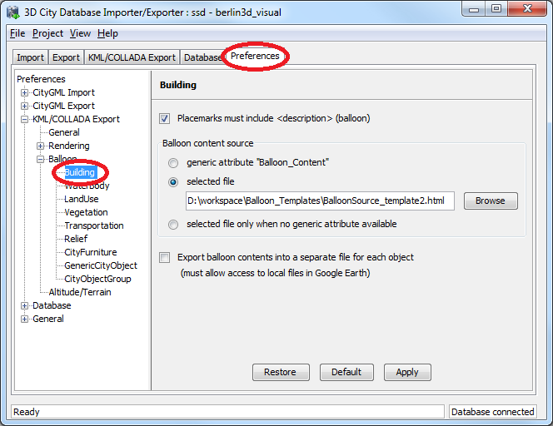
Fig. 17: Building Balloon settings.
The balloon contents do not need to be static. They can contain references to the data belonging to the city object they relate to. These references will be dynamically resolved (i.e.: the actual value for the current object will be put in their place) at export time in a way similar to how Active Server Pages (ASP) [5] work. Placeholders embedded in the HTML template, beginning with <3DCityDB> and ending with </3DCityDB> tags, will be replaced in the resulting balloon with the dynamically determined value(s). The HTML balloon templates can also include JavaScript code.
For all concerns, including dynamic content generation, it makes no difference whether the template is taken from the Balloon_Content generic attribute or from an external file.Balloon template format
As previously stated, a balloon template consists of ordinary HTML, which may or may not contain JavaScript code and <3DCityDB> placeholders for object-specific content. These placeholders follow several elementary rules:
Rules for simple expressions
- expressions begin with <3DCityDB> and end with </3DCityDB>. Expressions are not case-sensitive.
- expressions are coded in the form "TABLE/[AGGREGATION FUNCTION] COLUMN [CONDITION]". Aggregation function and condition are optional. When present they must be written in square brackets (they belong to the syntax). These expressions represent an alternative coding of a SQL select statement: SELECT [AGGREGATION FUNCTION] COLUMN FROM TABLE [WHERE condition]. Tables refer to the underlying 3DCityDB table structure (see [1] for details).
- Each expression will only return those entries relevant to the city object being currently exported. That means an implicit condition clause somewhat like "TABLE.CITYOBJECT_ID = CITYOBJECT.ID" is always considered and does not need to be explicitly written.
- Results will be interpreted and printed in HTML as lists separated by commas. Lists with only one element are the most likely, but not exclusively possible, outcome. When only interested in the first result of a list the aggregation function FIRST should be used. Other possible aggregation functions are LAST, MAX, MIN, AVG, SUM and COUNT.
- Conditions can be defined by a simple number (meaning which element from the result list must be taken) or a column name (that must exist in underlying 3DCityDB table structure) a comparison operator and a value. For instance: [2] or [NAME = 'abc'].
- Invalid results will be silently discarded. Valid results will be delivered exactly as stored in the 3DCityDB tables. Later changes on the returned results - like substring() functions - can be achieved by using JavaScript.
- All elements in the result list are always of the same type (the type of the corresponding table column in the underlying 3DCityDB). If different result types must be placed next to each other, then different <3DCityDB> expressions must be placed next to each other.
Special keywords in simple expressions
- Starting from the Importer/Exporter version 1.5.0 balloon template files have been enhanced with new additional placeholders for object-specific content, called SPECIAL_KEYWORDS. They refer to data that is not retrieved “as is” in a single step from a table in the 3DCityDB but has to undergo some processing steps (not achievable by simple JavaScript means) in order to calculate the final value before being exported to the balloon. A typical processing step is the transformation of some coordinate list into a CRS different from the one the 3DCityDB is originally set in. The coordinates in the new CRS cannot be included in the balloon with their original values as read from the database (which was the case with all other expression values so far), but must be transformed prior to their addition to the balloon contents.

- Expressions for special keywords are not case-sensitive. Their syntax is similar to ordinary simple expressions, start and end are marked by <3DCityDB> and </3DCityDB> tags, the table name must be SPECIAL_KEYWORDS (a non-existing table in the 3DCityDB), and the column name must be one of the following:

CENTROID_WGS84 (coordinates of the object’s centroid in WGS84 in the following order: longitude, latitude, altitude)
CENTROID_WGS84_LAT (latitude of the object’s centroid in WGS84)
CENTROID_WGS84_LON (longitude of the object’s centroid in WGS84)
BBOX_WGS84_LAT_MIN (minimum latitude value of the object’s envelope in WGS84)
BBOX_WGS84_LAT_MAX (maximum latitude value of the object’s envelope in WGS84)
BBOX_WGS84_LON_MIN (minimum longitude value of the object’s envelope in WGS84)
BBOX_WGS84_LON_MAX (maximum longitude value of the object’s envelope in WGS84)
BBOX_WGS84_HEIGHT_MIN (minimum height value of the object’s envelope in WGS84)
BBOX_WGS84_HEIGHT_MAX (maximum height value of the object’s envelope in WGS84)
BBOX_WGS84_LAT_LON (all four latitude and longitude values of the object’s envelope in WGS84)
BBOX_WGS84_LON_LAT (all four longitude and latitude values of the object’s envelope in WGS84)

- No aggregation functions or conditions are allowed for SPECIAL_KEYWORDS. If present they will be interpreted as part of the keyword and therefore not recognized.

- The SPECIAL_KEYWORDS list is also visible and available in its current state in the updated version of the Spreadsheet Generator Plugin. The list can be extended in further Importer/Exporter releases.

Examples for simple expressions:

<3DCityDB>ADDRESS/STREET</3DCityDB>
returns the content of the STREET column on the ADDRESS table for this city object.
<3DCityDB>BUILDING/NAME</3DCityDB>
returns the content of the NAME column on the BUILDING table for this city object.
<3DCityDB>CITYOBJECT_GENERICATTRIB/ATTRNAME</3DCityDB>
returns the names of all existing generic attributes for this city object. The names will be separated by commas.
<3DCityDB>CITYOBJECT_GENERICATTRIB/REALVAL [ATTRNAME = 'H_Trauf_Min']</3DCityDB>
returns the value (of the REALVAL column) of the generic attribute with attrname H_Trauf_Min for this city object.
<3DCityDB>APPEARANCE/[COUNT]THEME</3DCityDB>
returns the number of appearance themes for this city object.
<3DCityDB>APPEARANCE/THEME[0]</3DCityDB>
returns the first appearance for this city object.
<3DCityDB>SPECIAL_KEYWORDS/CENTROID_WGS84_LON</3DCityDB>
returns the longitude value of this city object’s centroid longitude in WGS84.
<3DCityDB> simple expressions can be used not only for generating text in the balloons, but any valid HTML content, like clickable hyperlinks:
<a href="<3DCityDB>EXTERNAL_REFERENCE/URI</3DCityDB>"> click here for more information</a>
returns a hyperlink to the object's external reference,
or embedded images:
<img src= "<3DCityDB>CITYOBJECT_GENERICATTRIB/URIVAL [ATTRNAME='Illustration']</3DCityDB>" width=400>
This last example produces, for instance, in the case of the Pergamon Museum in Berlin:
<img src="http://upload.wikimedia.org/wikipedia/commons/d/
d1/FrisoaltarPergamo.jpg" width=400>
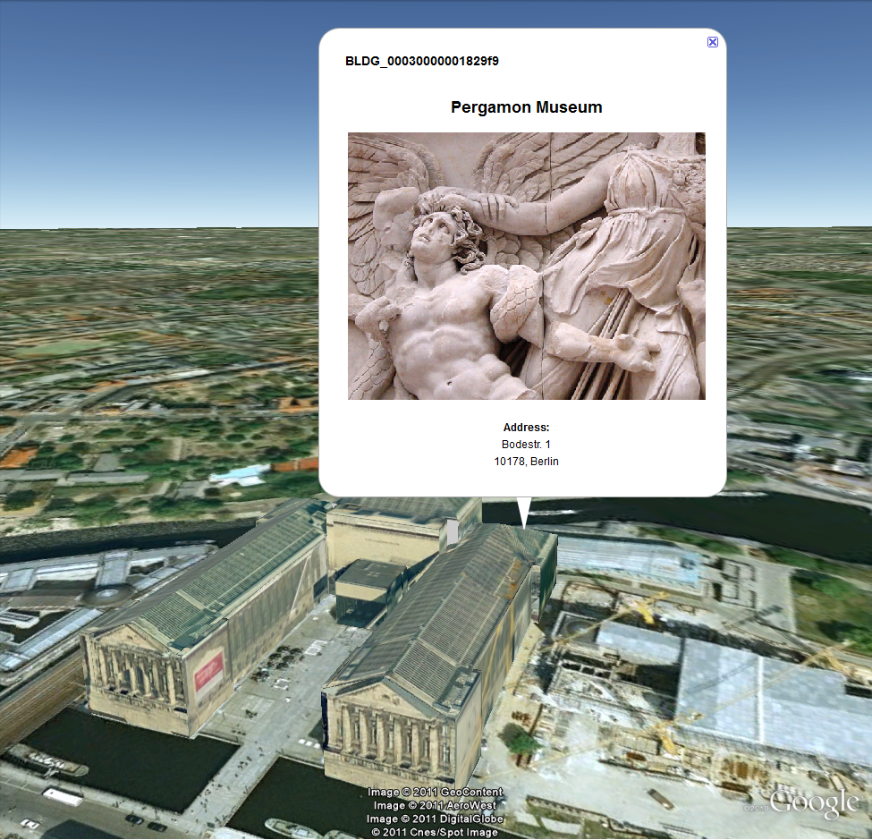
Fig. 18: Dynamically generated balloon containing an embedded image (image taken from Wikimedia).
Simple expressions are sufficient for most use cases, when only a single value or a list of values from a single column is needed. However, sometimes the user will need to access more than one column at the same time with an unknown amount of results. For these situations (listing of all generic attributes along with their values is one of them) iterative expressions were conceived.
Rules for iterative expressions
- Iterative expressions will adopt the form:
<3DCityDB>FOREACH
TABLE/COLUMN[,COLUMN][,COLUMN][...][,COLUMN][CONDITION]
</3DCityDB>
[...]
HTML and JavaScript code (column content will be referred to as %1, %2, etc. and follow the columns order in the FOREACH line. %0 is reserved for displaying the current row number)
[...]
<3DCityDB>END FOREACH</3DCityDB>
- No aggregation functions are allowed for iterative expressions. The amount of columns is free, but they must belong to the same table. Condition is optional. Implicit condition (data must be related to the current city object) applies as for simple expressions.
- FOREACH means truly "for each". No skipping is possible. If skipping at display time is needed it must be achieved by JavaScript means.
- The generated HTML will have as many repetitions of the HTML code between the FOREACH and END FOREACH tags as lines the query result has.
- No inclusion of simple expressions or SPECIAL_KEYWORDS between FOREACH and END FOREACH tags is allowed.
- No nesting of FOREACH statements is allowed.

Examples for iterative expressions:
Listing of generic attributes and their values:
<script type="text/javascript">
function ga_value_as_tooltip(attrname, datatype, strval,
intval, realval)
{
document.write("<span title=\"");
switch (datatype) {
case "1": document.write(strval);
break;
case "2": document.write(intval);
break;
case "3": document.write(realval);
break;
default: document.write("unknown");
};
document.write("\">" + attrname + "</span>");
}
<3DCityDB>FOREACH
CITYOBJECT_GENERICATTRIB/ATTRNAME,DATATYPE,STRVAL,
INTVAL,REALVAL</3DCityDB>
ga_value_as_tooltip("%1", "%2", "%3", "%4", "%5");
<3DCityDB>END FOREACH</3DCityDB>
</script>
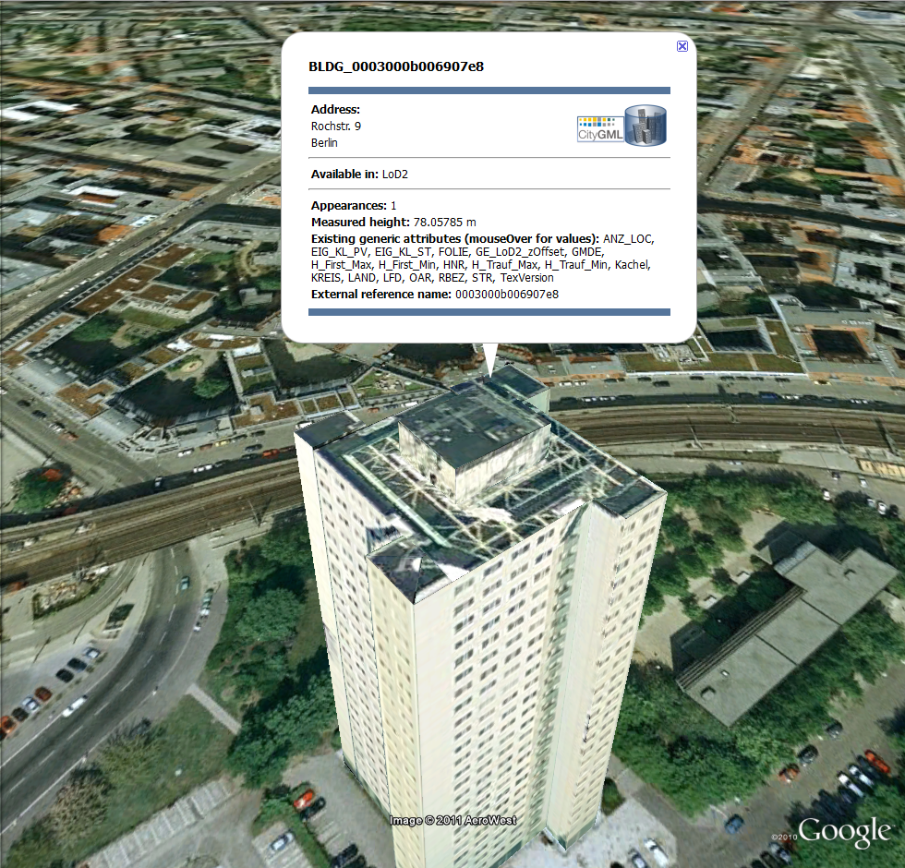
Fig. 19: Model placemark with dynamic balloon contents showing the list of generic attributes.

Altitude/Terrain Preferences
With reference systems other than WGS84 (the reference system used in Google Earth) in the underlying 3DCityDB, some adjustments on the z coordinate for the exported datasets may be necessary for a perfect display in the Earth browser.
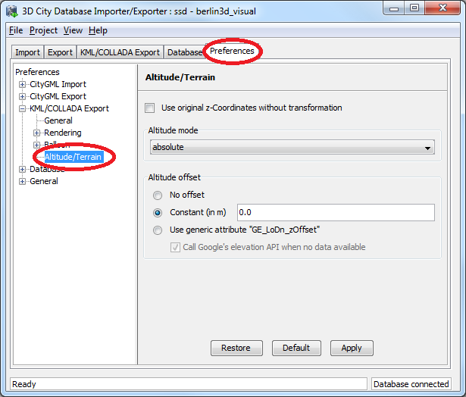
Fig. 20: Altitude/Terrain settings.
Use original z-Coordinates without transformation
Depending on the Oracle version (10g or 11g) of the database used, the transformation of the original coordinates to WGS84 will include transformation of the z-coordinates (11g) or not (10g). To make sure only the planimetric (x,y) and not the z-coordinates are transformed this checkbox must be selected. This is useful when the used terrain model is different from Google Earth’s and the z-coordinates are known to fit perfectly in that terrain model.
Another positive side-effect of this option is that GE_LoDn_zOffset attribute values (explained in the following section) calculated for Oracle 10g keep being valid when imported into Oracle 11g. Otherwise, when switching database versions and not making use of this option, GE_LoDn_zOffset values must be recalculated again.
GE_LoDn_zOffset attribute values calculated for Oracle 10g are consistent for all KML/COLLADA exports from Oracle 10g. The same applies to Oracle 11g. Only cross-usage (calculation in one version, export from the other) creates inconsistencies that can be solved by turning z-coordinate transformation off.
This setting affects the resulting GE_LoDn_zOffset if used when a cityobject has none such value yet and is exported in KML/COLLADA for the first time, so it is recommended to remember its status (z-coordinate transformation on or off) for all future exports.
Altitude mode
Allows the user to choose between relative (to the ground), interpreting the altitude as a value in meters above the terrain, or absolute, interpreting the altitude as an absolute height value in meters according to the vertical reference system (EGM96 geoid in KML).
This means, when relative altitude mode is chosen, the z-coordinates of the exports represent the vertical distance from the digital terrain model (DTM) of the Earth browser, which should be 0 for those points on the ground (the building's footprint) and higher for the rest (roof surfaces, for instance). However, z-coordinate values of the city objects stored in a 3DCityDB usually have values bigger than 0, so choosing this altitude mode will result most times in exports hovering over the ground.
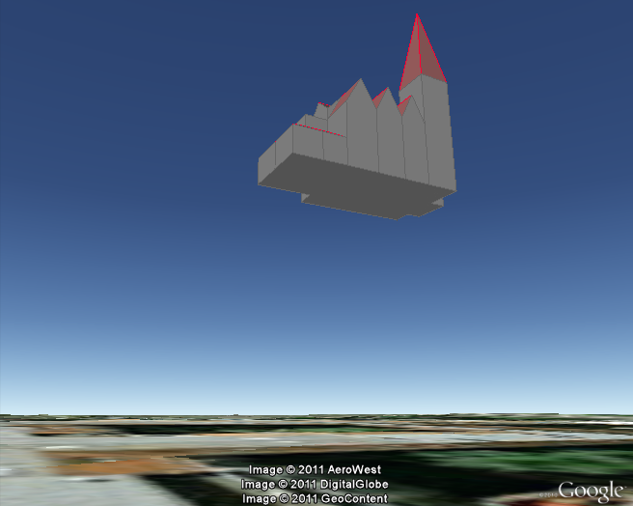
Fig. 21: Possible export result with relative altitude mode.
When absolute altitude mode is chosen, the z-coordinates of the exports represent the vertical distance from the vertical datum - the ellipsoid or geoid which most closely approximates the Earth curvature, for Google Earth this is the WGS84 EGM96 Geoid, see KML documentation [3] -, regardless of the DTM at that point. This implies, choosing this altitude mode may result in buildings sinking into the ground wherever the DTM indicates there is a hill or hovering over the ground wherever the DTM indicates a dent.
For a proper grounding, a positive or negative offset value can be applied to all z-coordinates of the exports, moving the city objects up and down along the z-axis until they match the ground.
Altitude offset
A value, positive or negative, can be added to the z coordinates of all geometries in one export in order to place them higher or lower over the earth surface. This offset can be 0 for all exported objects (no offset), it can be constant for all (constant), or it can have an individual value for each object stored in the object's generic attribute GE_LoDn_zOffset (where n stands for the corresponding level of detail in CityGML sense).
The first two options, no offset and constant, are appropriate for exports of a single city object, allowing some fine tuning of its position along the z-axis. When exporting regions - via bounding box settings -, the Use generic attribute "GE_LoDn_zOffset" option is recommended. Whenever possible (restrictions explained below) settings should be as displayed in Fig. 20, including absolute altitude mode. The GE_LoDn_zOffset generic attribute value can be automatically calculated by the KML/COLLADA exporter if not available. This calculation uses data returned by Google's Elevation API [4]. After calculation the value will be stored in the CITYOBJECT_GENERICATTRIB table of the 3DCityDB for future use.
Since city objects may have different geometries for different LoDs, the anchoring points and their elevation values may also differ for each LoD. This explains the need for having GE_LoD1_zOffset, GE_LoD2_zOffset, etc. generic attributes for one single object.
The algorithm used to calculate the individual zOffset for an object iterates over the points with the lowest z-coordinate in the object, calling Google's elevation API in order to get their elevation. The point with the lowest elevation value will be chosen for anchoring the object to the ground. The zOffset value results from subtracting the point's z-coordinate from the point's elevation value.
When calling Google's elevation API for calculating the zOffset of an object a message is shown: "Getting zOffset from Google's elevation service for BLDG_0003000e008c4dc4".
Google's elevation API imposes strong usage restrictions: non-premium users can issue a maximum of 2,500 requests per day. This limit may be reached fast when exporting areas where no city objects have GE_LoDn_zOffset values assigned. When the daily usage limit is reached a warning message is shown: "Elevation service returned OVER_QUERY_LIMIT". The usage limit is bound to the caller's IP address. It is advisable to use several different computers (or IP addresses) when filling the 3DCityDB with GE_LoDn_zOffset values (or become a premium user).
A second usage restriction allows for no more than 10 requests per second. The Import/Export tool takes care of not exceeding this limit by pausing between requests when required. That will slow down KML/COLLADA exports when done for the first time. Subsequent exports will be faster since the GE_LoDn_zOffset attribute value is already in the 3DCityDB and does not have to be calculated again.
Saving the building's height offset in the form of a generic attribute ensures this information will be present in every export in CityGML format (and therefore at every re-import) and can thus be transported across databases. Please note, that not the DTM height value of Google Earth will be stored but the difference of the individual building’s minimum z value and the value reported by the Google Elevation Service. Following this approach further usage restrictions of the Google Elevation Service are avoided.
In some unusual cases, even after automatic calculation of the GE_LoDn_zOffset value the object may still not be perfectly grounded to the Earth surface for a number of reasons; e.g. wrong height data of the model, or low resolution of the DTM at that area. In those cases a manual adjustment of the value in the 3DCityDB is needed. After the content of GE_LoDn_zOffset has been fine tuned to a proper value it should be persistently stored in the database.
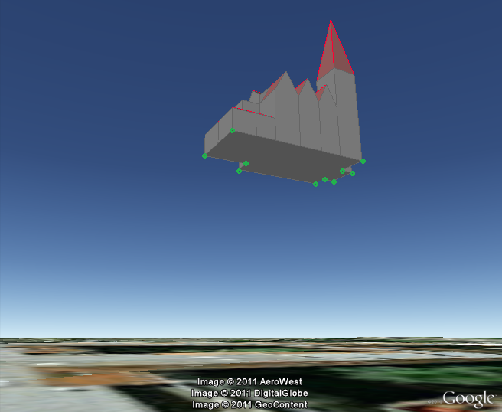
Fig. 22: Points sent to Google's Elevation API for calculation of the zOffset.
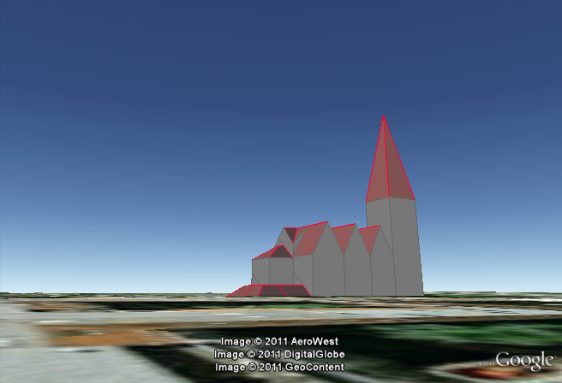
Fig. 23: Export with absolute altitude mode and no offset.

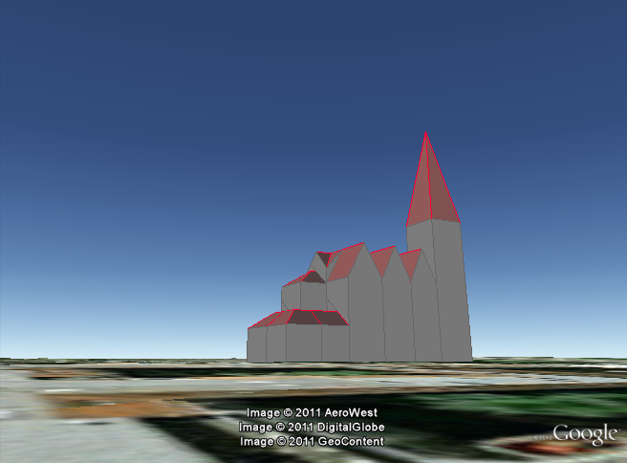
Fig. 24: Export with absolute altitude mode and use of GE_LoDn_zOffset.

Batch mode
Analog to the CityGML imports and exports, KML/COLLADA exports can also be executed from the shell without opening a graphical user interface. The command line syntax is:
java [options] -jar impexp.jar -shell –kmlExport
<export_filename> -config <config_filename>
[options] refers to all possible settings in the Java Virtual Machine (JVM) itself. One recommended option is –Xmx1024m, which sets the maximum heap size to 1GB. The user can adapt this value according to his/her hardware for optimal performance. Bigger heap sizes mean less often garbage collections and therefore improved performance. For a comprehensive list of all JVM options see [7].
- -shell tells the Import/Export tool to execute in a shell environment without graphical user interface.
- <export_filename> indicates the target file for the resulting exports.
- <config_filename> points to a configuration file containing the project settings. Configuration files can be explicitly created and stored by the Importer/Exporter tool by clicking on the menu "Project", "Save Project As...". Configuration files are written in .xml format and can be adapted with any text editor.

Loading exported models in Google Earth
Usage of the most up-to-date Google Earth version is highly recommended. Some of the features described in this documentation, like highlighting, require version 6.0.1 to work flawlessly (they do work in older versions, but not as smooth).
Displaying a file in Google Earth can be achieved by opening it through the menu ("File", "Open") or double-clicking on any kml or kmz file if these extension are associated with the program (default option at Google Earth's installation time).
Loaded files can be refreshed when generated again after loading (if for example the balloon template file was changed) by choosing the "Revert" option in the context menu on the sidebar. There is no need to delete and load them again or shutdown or restart the Earth browser.
For best performance, cache options ("Tools", "Options", "Cache") should be set to their maximum values, 1024MB for memory cache size, 2000MB for disk cache. Actual maximums may be lower depending on the computer's hardware.
Recommended graphics mode ("Tools", "Options", "3D View") on Windows platforms is DirectX.
Show Terrain ("Tools", "Options", "3D View") should be enabled, quality set at around 1/3. Disable it only in the case exports cannot be seen although shown as loaded in Google Earth's sidebar: they are probably buried into the ground (see chapter 4.3.2.4), and remember to enable showing of the terrain again when loading the next unrelated exports.
When exporting balloons into individual files (one for each object) written together into a balloon directory access to local files and personal data must be allowed ("Tools", "Options", "General"). Google Earth will issue a security warning that must be accepted, otherwise the contents of the balloons (when in individual files and not as a part of the doc.kml file) will not be displayed.
It is also possible to upload the generated KML/COLLADA files to a web server and access them from there as a Network Link in Google Earth or via internet browser with installed Google Earth Plugin. In this case, as stated in chapter 4.3.2.1, export in kmz format is recommended and balloon content must be part of the doc.kml file. Due to security risks, the Plugin has no option for allowing access to local files and personal data.

General setting recommendations
When the original data are defined in a 3D reference system the Importer/Exporter will detect this before exporting to KML/COLLADA and automatically choose the target system with the same dimensionality (WGS84 for 2D, WGS84 3D for 3D) that must be applied for the coordinate transformation.
Depending on the quality and complexity of the 3DCityDB data, export results may vary greatly in aesthetic and loading performance. Experimenting will be required in most cases for a fine tuning of the export parameters. However, some rules apply for almost all cases:
- kmz format use is recommended when the files will be accessed over a network. Kml format seems to have a positive effect on the stability of the Earth browser.
- Visibility values for the different display forms should be increased in steps of around one third of the tile side length.
- Visibility from 0 pixels (always visible) should be avoided, especially for large or complex exports, because otherwise the Earth browser will immediately load all data at once since it all must be visible.
- Tile side length (whether tiling is automatic or manual) should be chosen so that the resulting tile files are smaller than 10MB. When single files are bigger than that Google Earth gets unresponsive. For densely urbanized areas, where many placemarks are crimped together a tile side length value between 50 and 100m should be used.
- When not exporting in the COLLADA display form, files will seldom reach this 10MB size, but Google Earth will also become unresponsive if the file loaded contains a lot of polygons, so do not use too large tiles for footprint, extruded or geometry exports even if the resulting files are comparatively small.
- Do not choose too small tile sizes, many of them may become visible at the same time and render the tiling advantage useless.
- Using texture atlas generation when producing COLLADA display form exports always results in faster model loading times.
- From all texture atlas generating algorithms, BASIC is the fastest (shortest generation time), TPIM the most efficient (highest used area/total atlas size ratio).
- Texture images can often be scaled down to 0.2 - 0.5 without noticeable quality loss. This depends, of course, on the quality of the original textures.
- Highlighting puts the same polygons twice in the resulting export files, one for the buildings themselves, one for their highlighting. This has a negative impact on the viewing performance. The more complex the buildings are the worse the impact. When highlighting is enabled for exports based on a CityGML LoD3 or higher Google Earth may become quite slow.
- Balloon generation is slightly more efficient when a single template file is applied for all exported objects.
- Optimal altitude/terrain settings for a proper grounding of the exports are as shown in Fig. 20: absolute altitude mode, use of generic attribute GE_LoDn_zOffset and call Google's elevation API when no data is available.
- When the Google's elevation API daily quota limit is reached you can continue the export on another computer, or you can change your IP address (or become a Google premium user). Repetitive running of the KML/COLLADA export may be required over several days until error message "OVER_QUERY_LIMIT" no longer appears.

Support for Coordinate Reference Systems (CRS)

General information
When setting up a new instance of the 3D City Database, a Coordinate Reference System (CRS) has to be provided as mandatory setup parameter. This CRS is used as default reference system for all spatial objects which are created and stored in the database instance as well as for building spatial indexes and performing spatial functions.
Oracle provides comprehensive support for different types CRSs. Both Oracle 10g and 11g support 2D coordinate systems which are classified into two types: Geographic2D and Projected. The first type of coordinate system specifies the longitude and latitude on the earth surface approximated by a reference ellipsoid and is also referred to as Geodetic coordinate system. Projected types of 2D coordinate systems specify how to project longitude and latitude values on a reference Geographic2D system to a two-dimensional Euclidean coordinate system. Starting from Oracle 11g, support for 3D coordinate systems has been added which are classified into the following three types: Geographic3D (Geographic2D plus ellipsoidal height), Geocentric (specifies x,y,z values with reference to the center of the earth), and Compound (combines either Geographic2D or Projected (2D) with a vertical coordinate system specifying height based on gravity, above mean sea level, etc.).
The 3D City Database and the Importer/Exporter are designed to support both Oracle 10g (R2) and Oracle 11g (R1 and R2). When using Oracle 11g, both 2D and 3D reference systems are supported. Exports to CRS different from the original (see 4.6.1) require the dimensionality of the target and source system to be identical. That means, 2D reference systems must be transformed into 2D reference systems, 3D reference systems into 3D reference systems. Cross-dimensionality transformation (2D to 3D or 3D to 2D) is not supported. Oracle 11g comes with a few predefined 3D CRS. Their coverage is limited, so a manual definition of a new 3D CRS is usually required for most areas. An Importer/Exporter plugin is currently being developed especially for this purpose (definition of 3D CRS).
Regardless of the CRS associated with a spatial object, the spatial data types offered by both Oracle 10g and 11g fully support three-dimensional coordinate values. This is important with respect to the storage of geometries in the 3D City Database: Since the 3D City Database is meant to store and manage virtual 3D city models based on CityGML, and CityGML is a true 3D standard, all geometries are stored with three-dimensional coordinate values in the 3D City Database. There are only very few exceptions to this rule, where geometries with two-dimensional coordinate values are allowed in CityGML (please refer to the CityGML specification [2] for details).
Note: Transformation of stored three-dimensional coordinates which refer to a 2D CRS can result in some small degree of inaccuracy affecting not only the output height of a transformation, but also possibly the longitude and latitude, see [15] for details.

Definition of the CRS for a 3D City Database instance
The definition of the CRS for setting up a new instance of the 3D City Database consists of two components: 1) a valid Oracle Spatial Reference Identifier (SRID) and 2) an OGC GML conformant definition identifier for the CRS. Both components are stored in the table DATABASE_SRS. The CRS definition is fixed and shall not be changed at any later point in time (please refer to the chapter 3.2 of the previous 3D City Database 2.0.1 documentation [1] for more information about the setup procedure).
The SRID is an integer value key pointing to spatial reference information within Oracle’s MDSYS.CS_SRS table. Oracle is shipped with a large number of predefined spatial reference systems. At setup time, the SRID chosen as default value for the 3D City Database instance must already exist in MDSYS.CS_SRS.
The GML conformant CRS definition identifier is used as value for the gml:srsName attribute on GML geometry elements when exporting database contents to CityGML instance documents. It should follow the OGC recommendation for the Universal Resource Name (URN) encoding of CRSs given in the OGC Best Practice Paper Definition identifier URNs in OGC namespace [13]. At setup time, please make sure to provide a URN value which corresponds to the spatial reference system identified by the default SRID of the database instance. Since CityGML is a 3D standard, the URN encoding shall always represent a three-dimensional CRS which, for example, can be denoted as compound coordinate reference systems [13]. The general syntax of a URN encoding for a compound reference system is as follows:
urn:ogc:def:crs,crs:authority:version:code,crs:authority:
version:code
Authority, version, and code depend on the information authority providing the CRS definition (e.g. EPSG or OGC). The following example shows a possible combination of an SRID (here referring to a 2D CRS) and CRS URN encoding (3D) to set up an instance of the 3D City Database:
SRID: 31466
URN: urn:ogc:def:crs,crs:EPSG:7.7:31466,crs:EPSG:7.7:5783
The example SRID is referencing a Projected CRS defined by EPSG (DHDN / 3-degree Gauss-Krüger zone 2; used in the western part of Germany; EPSG-Code: 31466). The URN encodes a compound coordinate reference system which adds a Vertical CRS as height reference (DHHN92 height, EPSG-Code: 5783).

Management of user-defined CRSs
Version 1.2.2 of the Importer/Exporter already introduced the possibility to pass coordinate values given in a different CRS than the internal database CRS as input values for a spatial bounding box filter when importing/exporting CityGML documents. However, the support for further CRSs was still preliminary in such that a user could only choose from a predefined and fixed number of CRSs.
Release 1.4.0 of the Importer/Exporter brought full support for user-defined CRSs. Similar to the CRS information that has to be provided at setup time of a new 3D City Database instance, a user-defined CRS consists of both an Oracle SRID and a GML conformant URN encoding of the CRS. For the management of user-defined CRSs, a new user dialog was added to the Preferences tab as shown in the Fig. 25.
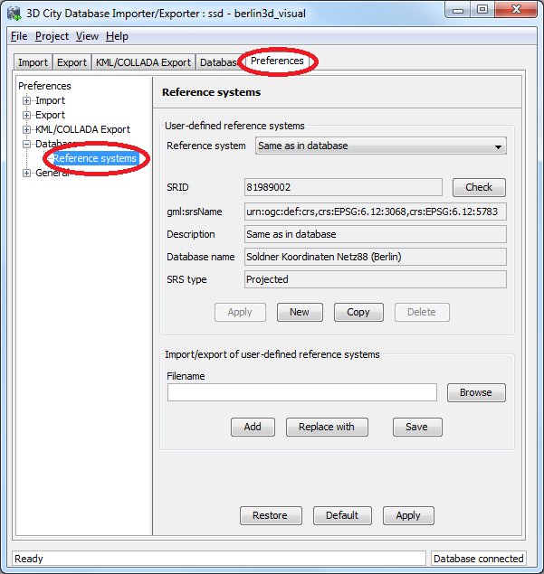
Fig. 25: Support for user-defined CRSs in the Preferences tab.
The management of user-defined CRSs can be found in the Reference systems subnode of the Database preferences node (the latter one is also introduced with release 1.4.0, cf. chapter 4.8). On top of the preferences page, a combo allows for choosing a CRS for display and editing from the list of user-defined CRSs. The list contains at minimum one predefined entry called Same as in database which represents the internal CRS of the 3D City Database instance. This entry will always show the SRID and CRS URN encoding of the currently connected database instance. Since the internal CRS shall not be changed after database setup, the fields of the Same as in database entry cannot be edited (cf. Fig. 25.).
A new user-defined CRS can be added to this list after clicking the New button. Please provide an Oracle SRID in the corresponding SRID input field of the user dialog and pass a corresponding URN encoding to the gml:srsName input field (optional). A short, meaningful textual description of the CRS has to be given in the Description field. This description is used as key value for the list of user-defined CRSs displayed in the combo box on top (and also in similar combo boxes on further tabs of the Importer/Exporter). The new CRS is added to the list of user-defined CRSs by clicking on the Apply button. The following screenshot provides an example.
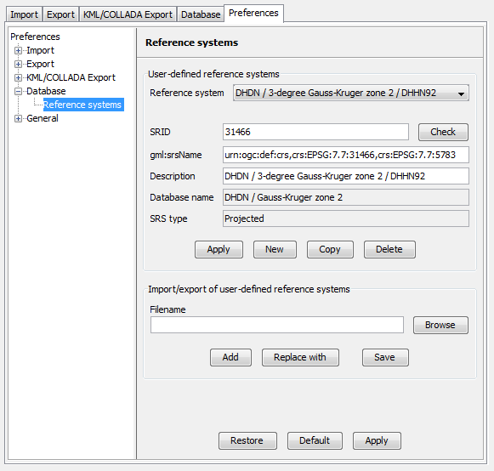
Fig. 26: Adding a new CRS to the list of user-defined CRSs.
The Copy button allows for adding a further CRS by copying and editing the information of an already existing user-defined CRS. The currently selected CRS is deleted from the list by clicking the Delete button. The Check button next to the SRID input field facilitates to verify whether the provided SRID is supported by the currently connected 3D City Database instance. After a successful check the non-editable fields Database name and SRS type will be filled with the corresponding information collected from the currently connected 3D City Database instance. If the Importer/Exporter is not connected to a database instance, the Check button is disabled.
The result of the SRID verification may vary between different 3D City Database instances due to the fact that a) the list of predefined spatial reference systems differs between different versions of Oracle Spatial (e.g., between 10g R2 and 11g R2) and b) the fact, that Oracle also supports the definition of user-defined spatial reference systems (please check the Oracle Spatial documentation for further guidance on how to create spatial reference systems in Oracle). In order to add a user-defined CRS to the Importer/Exporter which is not supported by the underlying Oracle Spatial database by default, this CRS has first to be registered with the internal Oracle tables. As soon as the CRS is announced to Oracle, it can be added to the list of user-defined CRSs in the Importer/Exporter.
The list of user-defined CRSs is automatically stored in the project settings of the Importer/Exporter and loaded upon application start. It can additionally be exported into an extra file without the remaining project settings. This allows for easily sharing user-defined CRSs between different Importer/Exporter installations. Please provide a valid filename in the corresponding input field Filename (clicking on the Browse button opens a dialog which allows for choosing a file) and click on Save. There are two options for importing such an external list of CRSs: 1) the CRSs listed in the external file can be added to the current list of CRSs (Add button) or 2) the external list can be used to replace the current list (Replace with button).
The Importer/Exporter is shipped with a number of predefined CRSs organized in subfolders of templates/CoordinateReferenceSystems within the installation folder of the Importer/Exporter. Each CRS definition is stored in its own file and, thus, can be easily imported and added to the list of user-defined CRSs. The URN encoding of the predefined CRSs generally lacks a height reference system which has to be added before using this CRS as target reference system for CityGML exports (cf. chapter 4.6.1 for more details).

Usage of user-defined CRSs
User-defined CRSs can be used at the following locations within the Importer/Exporter:
- Defining the CRS for the bounding box filter on the CityGML Import tab,
- Defining the CRS for the bounding box filter on the CityGML Export tab,
- Defining the CRS for the bounding box filter on the KML/COLLADA Export tab (cf. chapter 4.3), and
- Defining the target CRS for a coordinate transformation during CityGML exports on the Export tab (cf. chapter 4.6.1).
The following Fig. 27 shows an example usage of the CRS which has been added to the list of user-defined CRSs in the previous chapter. The CRS is applied to the spatial bounding box filter on the CityGML Import tab by choosing the corresponding value from the combo box. The Importer/Exporter will use this CRS information for the interpretation of the coordinate values passed to the Xmin, Xmax, Ymin and Ymax input fields and automatically transform them to the internal CRS of the 3D City Database instance in order to apply the spatial filter.
Often the bounding box used as a spatial filter for a CityGML import/export or KML/COLLADA export is derived from querying a public web-based map service such as Google Maps, Microsoft Bing Maps, or OpenStreetMap. Usually, points on these maps have latitude and longitude values according to the WGS84 ellipsoid and datum. If you want to directly make use of the map coordinate values in the spatial bounding box filters of the Importer/Exporter, you first have to add a user-defined CRS for WGS84 and choose this as reference system for the corresponding filter. The Importer/Exporter is shipped with a predefined CRS definition for WGS84. This can be loaded from an external file which is located in the subfolder templates/CoordinateReferenceSystems within the installation folder of the Importer/Exporter.
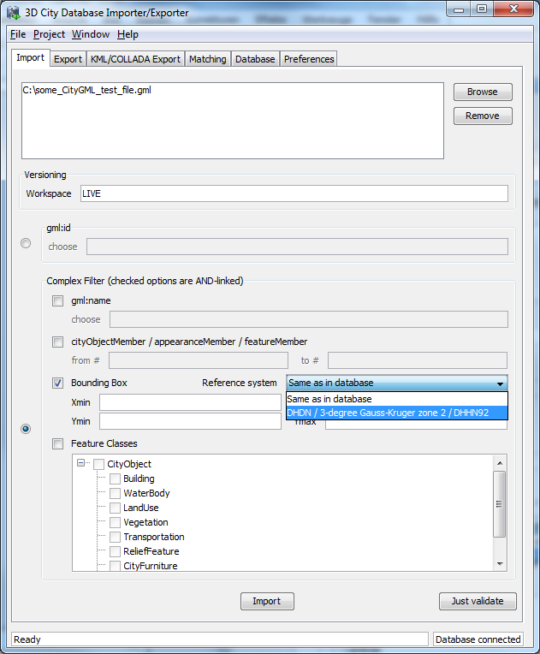
Fig. 27: Example usage of a user-defined CRS for specifying the reference system of the spatial bounding box filter applied to a CityGML import.
Since not every user-defined CRS is necessarily supported by the Oracle Spatial database, the Importer/Exporter verifies all CRSs upon every database connection. If a user-defined CRS is not supported by the Oracle Spatial database underlying the 3D City Database, a corresponding warning message is logged in the console window. The CRS combo boxes on the CityGML Import/Export tab and KML/COLLADA Export tab are smart in such they only offer a subset of CRSs which is supported by the currently connected database.

Support for 3D CRS
Support for 3D CRS was improved with release 1.4.0. The 3D City Database can be set up on a compound or geographic 3D system and the Importer/Exporter shall support all data operations including import, export and KML/COLLADA export the same as for all 2D CRS so far. Consequently, 3D CRS are managed through the same Preferences tab, Database node, Reference systems subnode as their 2D counterparts.
A geographic 3D CRS consists of a geographic 2D CRS plus ellipsoidal height, with longitude, latitude, and height based on the same ellipsoid and datum. A compound CRS consists of either a geographic 2D CRS plus gravity-related height or of a projected 2D plus gravity-related height.
When a CRS belonging to one of these two types is met it can be immediately recognized by the contents of the SRS type field, see Fig. 28.
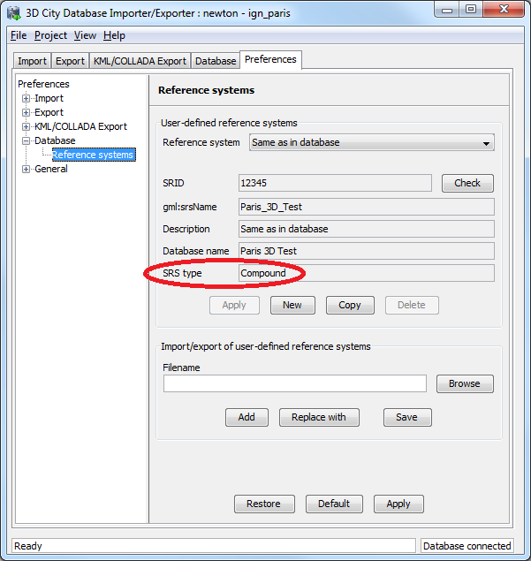
Fig. 28: A compound 3D CRS
When exporting 3D City Database contents into CityGML format the choice list Reference Systems on the Export tab will be automatically adapted to only show suitable 3D CRS the original data can be transformed into plus Same as in database (no transformation). Exporting to a 2D CRS when the original data comes from a 3D CRS will not be possible.
When exporting 3D City Database contents into KML/COLLADA format the Importer/Exporter will automatically identify whether the original data were defined in a 2D or in a 3D CRS and choose the target system WGS84 2D or WGS84 3D accordingly.

Support for Point and Line Geometries of GenericCityObjects
The feature type GenericCityObject as defined within CityGML’s Generics module (see [2]) allows for modeling and exchanging of 3D city objects which are not covered by any other thematic module of the CityGML data model. In every LOD, the spatial characteristics of a GenericCityObject can be described by an arbitrary 3D geometry object being a subtype of gml:_Geometry (the root of the GML geometry hierarchy). Thus, a GenericCityObject may be geometrically represented by one or more points, lines, surfaces, or volume objects per LOD.
As for example, GenericCityObjects can be used to model network structures such as water or power supply networks (which are not predefined by the current CityGML specification) with every GenericCityObject representing either a junction or an edge of the network. In LOD1, this network might be spatially embedded using point and line geometries. However, until release 1.5.0 of the Importer/Exporter, only surface-based and volumetric representations of generic city objects were supported and kept in the SURFACE_GEOMETRY table. The exemplified network structure would hence be lost during the database import.
This limitation has been resolved in 1.5.0 which additionally enables the storage of point and line geometries. In order to keep the 3DCityDB database model unchanged for this minor release, non-surface-based representations of generic city objects are saved in the table CITYOBJECT_GENERICATTRIB according to the following scheme:
- The ATTRNAME column follows the pattern “LODn_Geometry”, where n stands for the LOD of the GenericCityObject which is captured by the geometry object (i.e., LOD0_Geometry, LOD1_Geometry, etc.).
- The geometry itself is mapped onto an instance of SDO_GEOMETRY and stored in the GEOMVAL column. The SDO_TYPE field of the SDO_GEOMETRY object is restricted to 3001 for point geometries and to 3002 respectively 3006 for line strings (whose vertices are required to be connected by straight line segments).
- The DATATYPE field takes the value “6” which encodes a geometry attribute.
When exporting a GenericCityObject, first the SURFACE_GEOMETRY table is scanned whether it holds a geometry representation of the feature for a given LOD. If no surface-based geometry is found, the CITYOBJECT_GENERICATTRIB table is searched for a point or line geometry associated with the feature by looking for a tuple whose ATTRNAME agrees with the pattern “LODn_Geometry” and matches this LOD. If such a tuple exists, its GEOMVAL value is used to populate the respective “lodnGeometry” property of the GenericCityObject being exported.
Note: According to the CityGML specification, a GenericCityObject feature may have at most one gml:_Geometry representation in each LOD. Correspondingly, per LOD, a tuple in GENERIC_CITYOBJECT may either reference a surface-based geometry stored in SURFACE_GEOMETRY or a single point respectively line geometry from CITYOBJECT_GENERICATTRIB but not both.
Note: The spatial representation of a GenericCityObject can be given as complex geometry using a gml:GeometricComplex which is allowed to contain geometric elements from different dimensions (e.g., a heterogeneous collection of points, lines, and surface-based geometries). Although Oracle Spatial generally supports storing heterogeneous collections of geometric elements in a single SDO_GEOMETRY object, very few of its spatial functions can be applied to such collections. For this reason, only homogeneous elements of the complex are considered when importing. First, the complex is checked whether it merely contains points or lines, in which case the point respectively line geometry is stored in CITYOBJECT_GENERICATTRIB as explained above. If this check fails, surface-based primitives contained in the complex are saved in the SURFACE_GEOMETRY table while silently discarding all non-surface-based primitives. The latter conforms to the behavior of previous releases.

CityGML Import Enhancements

Address storage
CityGML relies upon the OASIS Extensible Address Language (xAL) standard for the representation and exchange of address information. xAL provides a flexible and generic framework for encoding address data according to arbitrary address schemes. The columns of the ADDRESS table of the 3DCityDB however only map the most common fields in address records. Moreover, the Importer/Exporter currently does not support arbitrary xAL fragments but is tailored to the parsing of two xAL templates which are documented in [2] and presented below.

<bldg:Building>
…
<bldg:address>
<Address>
<xalAddress>
<!-- Bussardweg 7, 76356 Weingarten, Germany -->
<xAL:AddressDetails>
<xAL:Country>
<xAL:CountryName>Germany</xAL:CountryName>
<xAL:Locality Type="City">
<xAL:LocalityName>Weingarten</xAL:LocalityName>
<xAL:Thoroughfare Type="Street">
<xAL:ThoroughfareNumber>7</xAL:ThoroughfareNumber>
<xAL:ThoroughfareName>Bussardweg</xAL:ThoroughfareName>
</xAL:Thoroughfare>
<xAL:PostalCode>
<xAL:PostalCodeNumber>76356</xAL:PostalCodeNumber>
</xAL:PostalCode>
</xAL:Locality>
</xAL:Country>
</xAL:AddressDetails>
</xalAddress>
</Address>
</bldg:address>
</bldg:Building>

<bldg:Building>
…
<bldg:address>
<Address>
<xalAddress>
<!-- 46 Brynmaer Road Battersea LONDON, SW11 4EW United Kingdom -->
<!-- source: http://xml.coverpages.org/xnal.html -->
<xAL:AddressDetails>
<xAL:Country>
<xAL:CountryName>United Kingdom</xAL:CountryName>
<xAL:Locality Type="City">
<xAL:LocalityName>LONDON</xAL:LocalityName>
<xAL:DependentLocality Type="District">
<xAL:DependentLocalityName>Battersea
</xAL:DependentLocalityName>
<xAL:Thoroughfare>
<xAL:ThoroughfareNumber>46</xAL:ThoroughfareNumber>
<xAL:ThoroughfareName>Brynmaer Road
</xAL:ThoroughfareName>
</xAL:Thoroughfare>
</xAL:DependentLocality>
<xAL:PostalCode>
<xAL:PostalCodeNumber>SW11 4EW</xAL:PostalCodeNumber>
</xAL:PostalCode>
</xAL:Locality>
</xAL:Country>
</xAL:AddressDetails>
</xalAddress>
</Address>
</bldg:address>
</bldg:Building>

Fig. 29: xAL fragments currently supported by the Importer/Exporter

When xAL address information in a CityGML instance document does not comply with any of the two supported xAL templates (because they contain additional or completely different entries) the address information will only be partially stored in the database if it can be stored at all. In order to save any given address information and be able to recover it without information loss the whole <xal:AddressDetail> XML fragment can be imported ‘as is’ from the original CityGML file and stored in the XAL_SOURCE column of the ADDRESS table in the 3DCityDB. Simply select the Import original <xal:AddressDetail> XML checkbox under the Preferences tab, Import node, Address subnode. This option is switched on by default. Note that the import of the xAL fragment does not affect the filling of the remaining columns in the ADDRESS table (STREET, HOUSE_NUMBER, etc).
The symmetrical setting for CityGML exports (recovering the XML fragment from XAL_SOURCE) is explained in section 4.6.3

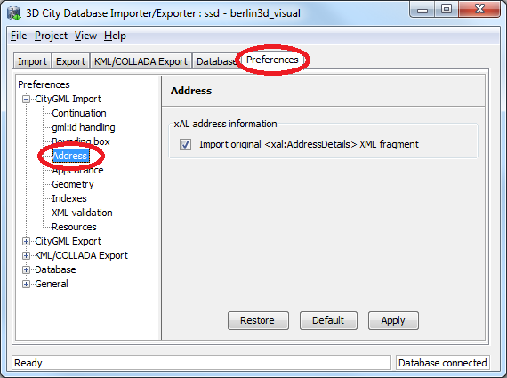
Fig. 30: Import the original city object's address as XML fragment

Affine Coordinate Transformation
With release 1.4.0 of the Importer/Exporter, affine coordinate transformation was added to the CityGML import functionality: This feature is located under the Preferences tab, Import node, Geometry subnode. An affine transformation is any transformation that preserves collinearity (i.e., points lying on a line initially still lie on a line after transformation) and ratios of distances (e.g., the midpoint of a line segment remains the midpoint after transformation) [14]. It will move lines into lines, polylines into polylines and polygons into polygons while preserving all their intersection properties. Geometric contraction, expansion, dilation, reflection, rotation, skewing, similarity transformations, spiral similarities, and translation are all affine transformations, as are their combinations [14].
Affine transformations are applied at the very moment of the import, before the new (and transformed) data is written and committed into the 3D City Database.
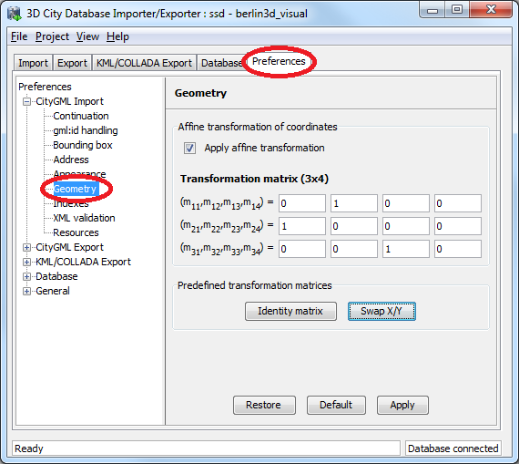
Fig. 31: Location of the new affine coordinate transformation feature
The affine transformation is defined as the result of the multiplication of the original coordinate vectors by a matrix plus the addition of a translation vector.
$${\vec{p}}^{'}=A∙\vec{p}+\vec{b}$$
In matrix form using homogenous coordinates:
$$\left[\begin{matrix}x^{'} \\ y^{'} \\ z^{'}\end{matrix}\right]=\left[\begin{matrix}m_{11} & m_{12} & m_{13} & m_{14} \\ m_{21} & m_{22} & m_{23} & m_{24} \\ m_{31} & m_{32} & m_{33} & m_{34}\end{matrix}\right]∙\left[\begin{matrix}x \\ y \\ z \\ 1\end{matrix}\right]$$
The coefficients of this matrix and translation vector can be entered as seen in Fig. 31. The first three columns define any linear transformation; the fourth column contains the translation vector. The affine transformation does not affect the dimensionality or the CRS system of the original model, just the object coordinate values are changed. It is applied the same to all coordinates in all objects in the original CityGML file. This includes all matrix structures present in CityGML like the 2x2 matrixes of GeoreferencedTextures, the 3x4 transformation matrixes of TexCoordGen elements used for texture mapping and the 4x4 transformation matrixes for ImplicitGeometries.
An affine transformation cannot be undone or reversed either in the 3D City Database itself or at export time. Data that had an affine transformation applied upon import is handled as original.
Two elementary affine transformations are predefined and immediately ready for use. Identity matrix (leave all geometry coordinates unchanged), which serves as an explanatory example of how values in the matrix should be set, and swap x/y, which exchanges the values of x and y coordinates in all geometries (and thus performs a 90 degree rotation around the z axis) and is very useful for correcting CityGML datasets in which e.g. Northing and Easting values are in wrong order.
Example: for an ordinary translation of all city objects 100 meters to the east and 50 meters to the north (assuming all coordinate units are given in meters) the identity matrix must be applied together with the original translation values set as coefficients in the translation vector:
$${\vec{p}}^{'}=\left[\begin{matrix}1 & 0 & 0 & 100 \\ 0 & 1 & 0 & 50 \\ 0 & 0 & 1 & 0\end{matrix}\right]∙\vec{p}$$

Indexes
The Indexes preferences settings menu has been slightly simplified. Buttons for manual activation or deactivation of spatial or normal indexes can now be found on the database tab (see 4.8).
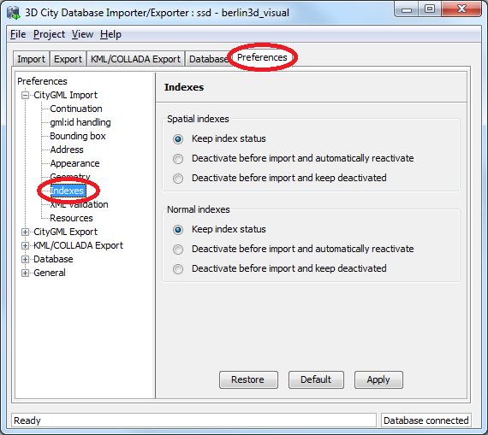
Fig. 32: Simplified import indexes preference settings

XML Validation
The XML Validation preference settings have not changed their location under the Import node, but they have also been simplified. The options Perform XML validation during database import and Just report one error per top-level feature remain, but the choice of the XML schema documents to be used for validation is suppressed. The internal functionality behind the latter option was kept, but the choice is now hard-wired and made easier for the user: validation of an element is dependent on its namespace:
- If the element’s namespace is part of the official CityGML 1.0.0 or CityGML 0.4.0 standard, it will be validated against the official CityGML 1.0.0 or CityGML 0.4.0 schema, which are both available locally (no internet access needed).
- If the element’s namespace is unknown the element will be validated against the schema pointed to by the xsi:schemaLocation value on the root element. This last validation step is necessary when, for instance, the input document contains XML content from a CityGML Application Domain Extension (ADE) and it requires a properly configured connection to the internet (see 4.9).
- If the element’s namespace is unknown and the xsi:schemaLocation value (provided either on the root node or the element itself) is empty validation will fail with a hint to the invalid element and the missing schema document.
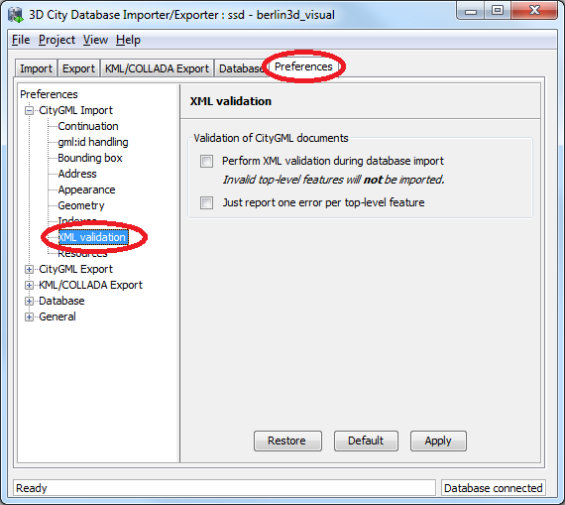
Fig. 33: Simplified (but functionally unchanged) XML validation preference settings.

CityGML Export Enhancements
With the release 1.3.0 of the Importer/Exporter, two new features were added to the CityGML export functionality: 1) performing a coordinate transformation to an arbitrary user-defined CRS, and 2) exporting the database content into tiles.

Coordinate Transformation
As discussed in the previous chapter 4.4, the geometry of city objects stored in the 3D City Database is internally associated with a fixed Coordinate Reference System (CRS) that has to be defined at database setup and shall not be changed afterwards.
Previous versions of the Importer/Exporter could only export data in that same CRS. Since release 1.3.0 the Importer/Exporter allows applying a coordinate transformation into another CRS during CityGML exports. A user-defined CRS must be provided as target reference system (cf. chapter 4.4 for guidance on the management of user-defined CRSs).
Using the CRS combo box at the top of the CityGML Export tab, simply choose the target reference system from the list of CRSs as seen in Fig. 34. The combo box will be automatically adapted to only show CRS having the same dimensionality as the original data plus Same as in database (no transformation). Exporting to a 3D CRS from original data in a 2D CRS or the other way around will not be possible.
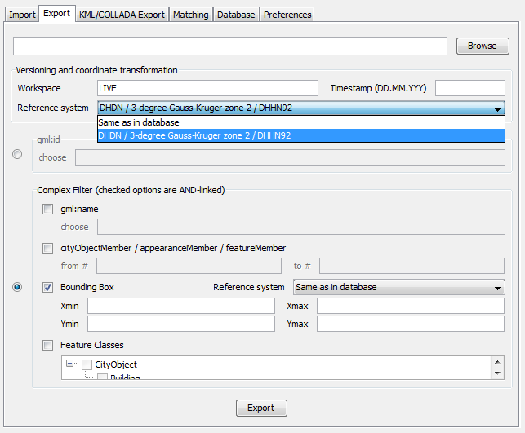
Fig. 34: Choosing a user-defined CRS as target reference system for a coordinate transformation applied during the CityGML export.
Note: For CityGML imports there is currently no automatic or user-definable coordinate transformation into the internal CRS of the 3D City Database instance available. Please make sure that the spatial reference system specified in the CityGML instance document matches the CRS of the 3D City Database instance prior to importing data. If the CRS of the CityGML instance document to be imported does not match, the following workaround procedure can be applied:
- Set up a second (temporary) instance of the 3D City Database with an internal CRS matching the CRS of the CityGML instance document.
- Import the dataset into this second 3D City Database instance.
- Export the data from this second instance into the target CRS by applying a coordinate transformation during the export as explained above.
- The exported CityGML document now matches the CRS of the target 3D City Database instance and can be imported into that database.
Support for coordinate transformations during CityGML imports will be added in future versions of the Importer/Exporter.

CityGML version
The previously called CityGML modules panel under the Export preferences has been renamed to CityGML version since release 1.4.0 and the contents were rearranged to be more user-friendly. Now the CityGML format version of the output document is constant through all elements (Core, Appearance, Building, etc.). The CityGML format version can be chosen to be v1.0.0 (OGC Encoding Standard), which is the default, or v0.4.0 (for compatibility in older environments). It is no longer possible to switch versions among the features from different CityGML modules within the same instance document.
Support for the new CityGML 2.0.0 standard will be included with the next major release scheduled for the first half of 2013.
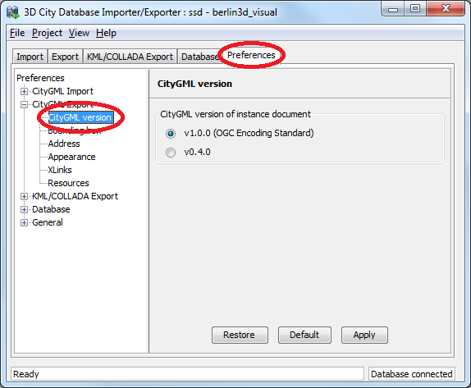
Fig. 35: Greatly simplified CityGML version choice for the output document

Address data reconstruction
As a counterpart to the enhancement regarding address storage for the CityGML import (see chapter 4.5.1), the address export capabilities have been consistently extended with release 1.5.0 of the Importer/Exporter.
Before this extension the address information exported to a CityGML file was composed exclusively from the data contained in the separate columns of the ADDRESS table in the 3DCityDB. As discussed in 4.5.1, these entries may not contain all data present in the original file or they may even contain no data at all when the address information differs too much from the two supported xAL templates shown in Fig. 29. In such cases, using the original <xal:AddressDetail> XML fragment previously saved in the XAL_SOURCE column is the only means to achieve a lossless reconstruction of the initial address data.
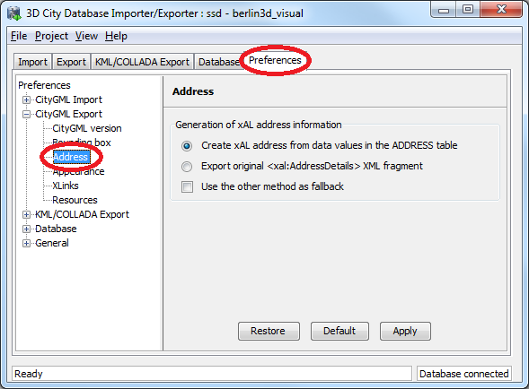
Fig. 36: Extended address export capabilities
Since the storage of the original <xal:AddressDetail> XML fragment at import time does not exclude the filling of the rest of the columns in the ADDRESS table (STREET, HOUSE_NUMBER, etc.) there are two possible ways to build up the address contents when exporting from the 3DCityDB: 1) the conventional mode, reading every single column entry and putting each value at its corresponding place on the xAL tree (according to the first template shown in Fig. 29); and 2) the lossless one, that simply takes the whole xAL fragment exactly as it was imported into the XAL_SOURCE column and inserts it literally as subelement of the <core:xalAddress> node of the city object being exported. These two methods are mutually exclusive but one can be used as a fallback alternative to the other if the first chosen renders no results. By default the first method will be chosen with no fallback alternative.

<bldg:Building>
…
<bldg:address>
<Address>
<xalAddress>
<!-- 46 Brynmaer Road Battersea LONDON, SW11 4EW United Kingdom -->
<!-- source: http://xml.coverpages.org/xnal.html -->
<xAL:AddressDetails>
<xAL:Country>
<xAL:CountryName>United Kingdom</xAL:CountryName>
<xAL:Locality Type="City">
<xAL:LocalityName>LONDON</xAL:LocalityName>
<xAL:DependentLocality Type="District">
<xAL:DependentLocalityName>Battersea
</xAL:DependentLocalityName>
<xAL:Thoroughfare>
<xAL:ThoroughfareNumber>46</xAL:ThoroughfareNumber>
<xAL:ThoroughfareName>Brynmaer Road
</xAL:ThoroughfareName>
</xAL:Thoroughfare>
</xAL:DependentLocality>
<xAL:PostalCode>
<xAL:PostalCodeNumber>SW11 4EW</xAL:PostalCodeNumber>
</xAL:PostalCode>
</xAL:Locality>
</xAL:Country>
</xAL:AddressDetails>
</xalAddress>
</Address>
</bldg:address>
</bldg:Building>

<bldg:Building>
…
<bldg:address>
<Address>
<xalAddress>
<!-- 46 Brynmaer Road Battersea LONDON, SW11 4EW United Kingdom -->
<!-- source: http://xml.coverpages.org/xnal.html -->
<xAL:AddressDetails>
<xAL:Country>
<xAL:CountryName>United Kingdom</xAL:CountryName>
<xAL:Locality Type="City">
<xAL:LocalityName>LONDON</xAL:LocalityName>
<xAL:Thoroughfare>
<xAL:ThoroughfareNumber>46</xAL:ThoroughfareNumber>
<xAL:ThoroughfareName>Brynmaer Road
</xAL:ThoroughfareName>
</xAL:Thoroughfare>
<xAL:PostalCode>
<xAL:PostalCodeNumber>SW11 4EW</xAL:PostalCodeNumber>
</xAL:PostalCode>
</xAL:Locality>
</xAL:Country>
</xAL:AddressDetails>
</xalAddress>
</Address>
</bldg:address>
</bldg:Building>

Fig. 37: Address build-up at export. First with the lossless method, recovering the whole <xal:AddressDetail> XML fragment, then with the conventional one. Notice the loss of the DependentLocality District Battersea information in the second case.

Unique texture filenames
For practical reasons, texture filenames in 3D models tend to be repetitive. They are often made up of a default prefix (e.g. ”tex”) and a number incremented by 1 for each new image. Such naming schemes are especially likely when texture names are assigned automatically. It is not an unusual case that texture names are repeated for two or more city objects within the same or different instance documents. This is not a problem for the storage in the 3D City Database, since the contents and names of the images are kept in separate records. But when exporting the CityGML model all texture files will be saved into the same subfolder (per tile), meaning that depending on the Overwrite settings in the Preferences (node Export, subnode Appearance) only the first or the last texture with that repeated name will be included in the model. This can lead to false visualizations when texture contents are applied to the wrong surfaces simply because their texture filenames happen to be identical to the texture filenames for some other unrelated surfaces. Further processing of the model (like importing in another 3D City Database) is discouraged since information got lost in the export process and the visualization errors will propagate.
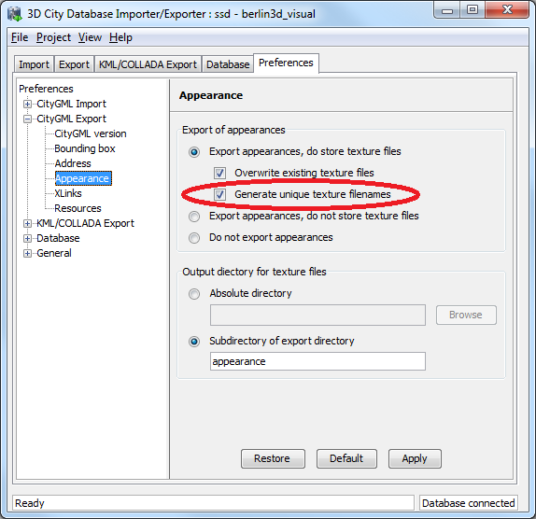
Fig. 38: Appearance preference option to generate unique texture filenames
There is a possibility to easily avoid that situation since version 1.4.0 of the Importer/Exporter Tool. Selecting the Generate unique texture filenames checkbox will ensure that all exported texture filenames in one export are different and no visualization conflict can arise. Since this is solved by replacing the original texture filenames with a combination of “tex” (constant) and the ID of the corresponding SURFACE_DATA entry in the 3DCityDB (which must be unique due to database constraints), the uniqueness of the resulting texture filenames is guaranteed not only for each export at a time but also among different exports of one and the same 3D City Database.
This feature is not required for KML/COLLADA exports. Exports in this format (regardless of the chosen kml/kmz extension) are divided into subfolders for each city object where texture filenames are necessarily unique.

Tiling
When exporting the entire 3D city model stored in the 3D City Database into a single CityGML instance document, the resulting file easily becomes very large. Although the Importer/Exporter supports writing files of arbitrary size (only limited by the file system of the operating system), such files may be too large to open in other applications. Furthermore, if the 3D city model is fully textured then the number of texture files exported into the same subfolder may become very high. This, in turn, may adversely affect the file access time.
Starting from its first release, the Importer/Exporter allows for applying a spatial bounding box filter to CityGML exports which helps in reducing the number of exported features and thus of the resulting file size. If however the area of interest is still comparatively large the user has to manually divide the area into smaller areas.
Starting from release 1.3.0, the Importer/Exporter provides the possibility to automatically tile the area specified by a bounding box filter. A corresponding user dialog has been added to the Preferences tab. It is available as subnode of the Export preferences node as shown in the following Fig. 39.
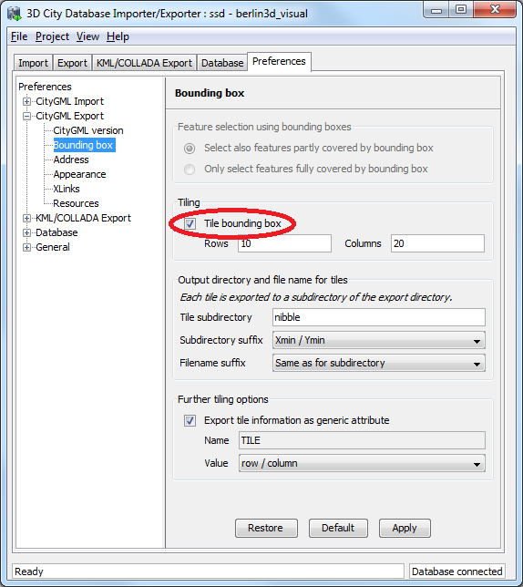
Fig. 39: Tiled export options under the Preferences Export tab.
Tiled exports are only available with the bounding box filter being enabled on the CityGML Export tab (further filters can of course additionally be used). To make use of the new tiling feature, please check the Tile bounding box option. If this option is unchecked, the only available settings for the bounding box filter are shown in the section Feature selection using bounding boxes on top of the user dialog. These settings have already been introduced in the first release of the Importer/Exporter and are used to indicate whether only objects fully covered by the bounding box will be exported or also those partially covered by it.
When tiling is selected, the Feature selection using bounding boxes section becomes inactive and all other options of this preferences tab are available. First, the number of rows and columns of the (resulting gridded) export must be specified. Space is distributed evenly among them, so that all rows have the same height and all columns the same width. To decide whether a feature has to be exported within a specific tile, the center of its envelope (column ENVELOPE of the table CITYOBJECT) has to be either inside or on the left or top border of the tile.
When exporting, a subdirectory will be created for each tile. These subdirectories are located beneath the main export directory specified on the CityGML Export tab. They all share a common freely choosable name part and a tile specific suffix. The suffix may contain the row and column number of the tile exported or a combination of the tile's minimum / maximum coordinates. If a coordinate suffix is chosen, the coordinates will be given in the reference system specified for the CityGML export (cf. chapter 4.6.1, default value is the internal SRS of the 3D City Database instance), even if the coordinates of the bounding box filter are given in another user-defined SRS. Thus it will be easier to track which object belongs to which tile, since the coordinates of the objects contained in the tile are exported in the same reference system. The file name of the CityGML instance document created per tile may also receive a tile specific suffix. If the corresponding option is selected, the suffix will be the same as for the tile directory.
For further traceability it is possible to attach a CityGML generic attribute called TILE to each exported feature, indicating which tile it belongs to. The options for identifying the tile (the value of this generic attribute) are the same as for the tile directory suffix.
Note: If the entire 3D city model stored in the 3D City Database instance shall be exported with the new tiling feature enabled, a bounding box spanning the overall area of the model has to be provided. This bounding box can be easily calculated using a new database operation introduced in release 1.4.0 which is available on the Database tab (cf. chapter 4.8).
Note: Using the center of an object’s envelope as topographical criterion for a tiled export leads to a side-effect when tiling is combined with the feature count filter on the CityGML Export tab: the number of objects being exported can no longer be exactly determined since the calculation of the object's envelope center must be done at a later point in time. Therefore, the feature count filter only sets a possible maximum value in this filter combination. For instance: when set to export cityObjectMember / appearanceMember / featureMember from #1 to #500, only #493 may be reached without the 3D City Database Importer/Exporter reporting any errors, since the missing 7 objects were discarded after being queried due to their envelope center not being within the tile.

Rework and Redesign of the Matching/Merging Tool
The Matching/Merging tool was substantially reworked in release 1.3.0 of the 3D City Database and the Importer/Exporter. In release 1.4.0 it was even separated from the core to become an optional plugin. First, identified bugs were fixed in the underlying PL/SQL database procedures. Second, the user interface was redesigned in order to improve usability. The goals of the Matching/Merging tool as well as its mode of operation and process workflow have not been changed in this release. Thus, the general description of the tool given in chapter 5 of the previous 3D City Database 2.0.1 documentation [1] still holds for this release. This section only presents additions to the former documentation.
User interface changes
The following Fig. 40 sketches the changes on the main tab Matching of the Importer/Exporter. Most of the changes result from rearranging GUI elements without modifying their original meaning. Settings related to candidate and master buildings have been grouped together to better grasp the input and output parameters for the matching/merging process.
The left hand side of Fig. 40 shows the previous design of the Matching/Merging tool as contained in version 1.2.2 of the Importer/Exporter. The redesigned layout shipped with version 1.4.0 is shown on the right. User input fields have been numbered. Input fields with identical meaning share the same number (shown in red). Green numbers are used to mark new input fields which were introduced with release 1.4.0.
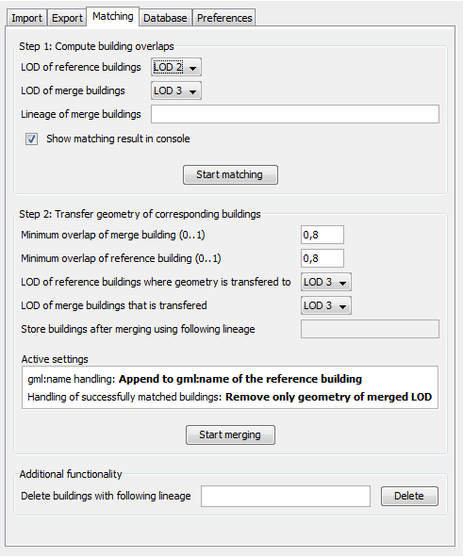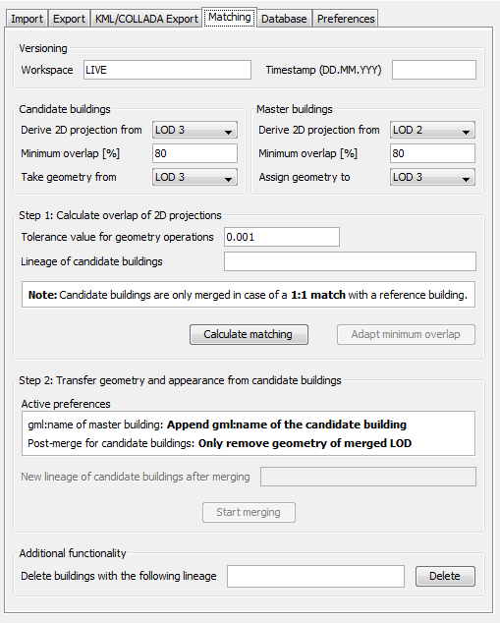
9
9
8
13
3
12
6
5
1
7
4
2
11
10
8
7
6
5
4
3
2
1
Fig. 40: Redesigned user interface of the matching/merging tool (left: the previous user interface as contained in version 1.2.2 of the Import/Export tool, right: the current user interface as contained in version 1.4.0 of the Import/Export tool). Corresponding input fields share the same numbering.
The Matching/Merging tool has been augmented with the following input fields and functionalities:
- Support for version-enabled databases
Similar to other tabs of the Import/Export tool, the input group Versioning has been added on top of the Matching tab. The two new fields Workspace (10) and Timestamp (11) allow for specifying an Oracle workspace on which the matching/merging process shall be executed (default is LIVE).
- Tolerance value for geometry operations
The tolerance input field (12) allows for defining a tolerance value which is passed to Oracle’s spatial functions used in the matching/merging process. Tolerance is used to associate a level of precision with spatial data and reflects the distance that two points can be apart and still be considered the same (for example, to accommodate rounding errors; please check the Oracle Spatial User's Guide and Reference for further information). The tolerance value is a number of the units that are associated with the internal CRS of the 3D City Database. For example, if the unit of measurements is meter, a tolerance value of 0.005 indicates a tolerance of 0.005 meter (that is, 1/200 meter), and a tolerance value of 2 indicates a tolerance of 2 meters. Please make sure to pick a reasonable value that fits your data.
- Adapt minimum overlap
Whether a candidate building and a master building are considered a match depends on the user-defined minimum overlap values for their projected 2D geometries (fields 4 and 5; cf. chapter 5.3 of the 3D City Database 2.0.1 documentation [1]). In the former 1.2.2 release, changing these values for a given set of candidates and masters required the restart of the entire matching procedure. The new button “Adapt minimum overlap” (13) allows for quickly influencing the matching result based on new minimum overlap values.
There are also minor changes to the Preferences section of the matching/merging tool as shown in Fig. 41.
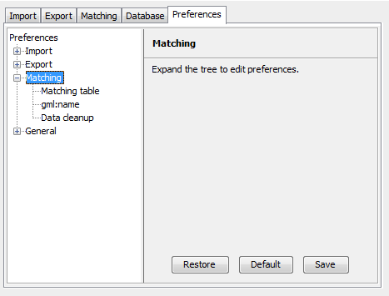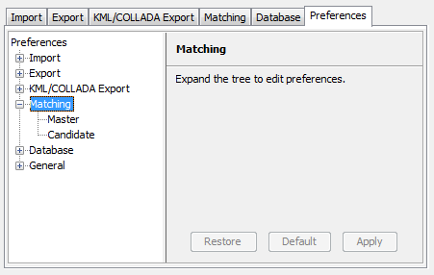
2
1
2
1
Fig. 41: Reworked preferences section of the matching/merging tool (left: the previous user interface as contained in version 1.2.2 of the Import/Export tool, right: the current user interface since version 1.4.0 of the Import/Export tool). Corresponding input fields share the same numbering.
The preferences node “gml:name” has been renamed to “Master“ since its settings only affect the master buildings in the merging process. For the same reason, “Data cleanup” has been renamed to “Candidate”. The contents of both preferences nodes remain the same as in the previous 1.2.2 release. Finally, “Matching table” has been entirely removed from the preferences section.
Bug fixes
The underlying PL/SQL procedures of the matching/merging tool were completely reworked for release 1.4.0 to fix identified bugs:
- Support for both Oracle 11g and 10g
The former version of the Matching/Merging tool was only designed for Oracle 10g R2. The matching/merging process will abort with errors on Oracle 11g R1 and Oracle 11g R2 when 3D coordinate reference systems are used for spatial objects. These bugs were fixed and the PL/SQL procedures now bring full support for Oracle 11g.
- Support for version-enabled databases
Older versions of the Matching/Merging tool did not correctly work on databases with version-enabled tables. This bug was fixed with release 1.4.0.
- Issues with moving appearances from candidates to master buildings
In some rare situations, appearances were not correctly moved from the candidate building to the matched master building. The processing of appearances was reworked to fix this bug.
The new PL/SQL procedures of the matching/merging tool are contained in the 2.0.6 distribution package of the 3D City Database (check files MATCH.sql and MERGE.sql in the subfolder ./oracle_spatial/PL_SQL/GEODB_PKG/MATCHING).

Extensions to the Database tab and preferences
The Database tab of the Importer/Exporter was augmented in release 1.3.0 with a Database operations section marked in red in the following Fig. 42. This part was further refined in release 1.4.0.
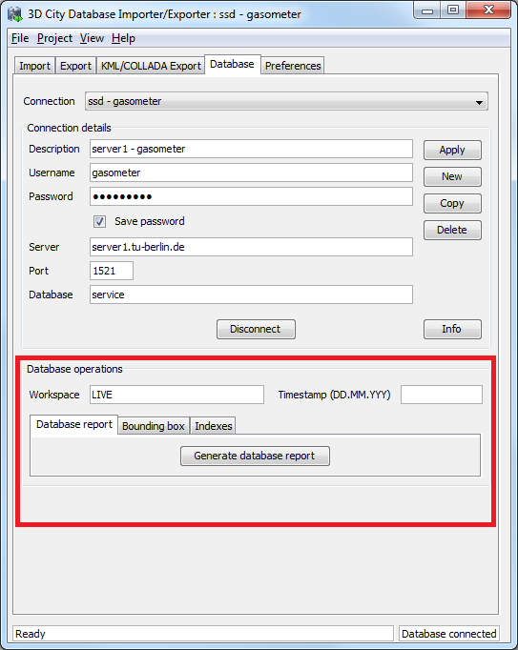
Fig. 42: Additions to the Database tab of the Importer/Exporter.
The new section contains three tabs enabling execution of the following operations after successfully connecting to a database:
- Generate database report
This functionality is already included since the 1.2.2 release of the Importer/Exporter and has not been changed with this release. The output is a list of all tables and the number of contained data rows printed to the console window.

- Calculate maximum bounding box
This operation allows for the calculation of the maximum bounding box of all city objects within the database. The resulting 2D coordinates of the bounding box (given as lower left corner and upper right corner) are filled in the fields Xmin, Ymin, Xmax, Ymax respectively and automatically copied to the clipboard. They can be used, for example, as input for the bounding box filters offered by the CityGML import and export as well as the KML/COLLADA export (you will need to paste the values).
The input city objects for the calculation of the bounding box can be restricted to a specific CityGML top-level feature type (e.g., Building, WaterBody, etc.). Furthermore, the resulting bounding box coordinates may be transformed to a different coordinate reference system (cf. chapter 4.4 for a description of the new support for user-defined CRS introduced with release 1.4.0).
The following Fig. 43 shows an example for the calculation of a maximum bounding box of a 3D City Database instance. The resulting bounding box is additionally transformed to the WGS84 reference system. For this purpose, a corresponding user-defined CRS (WGS84) was created.
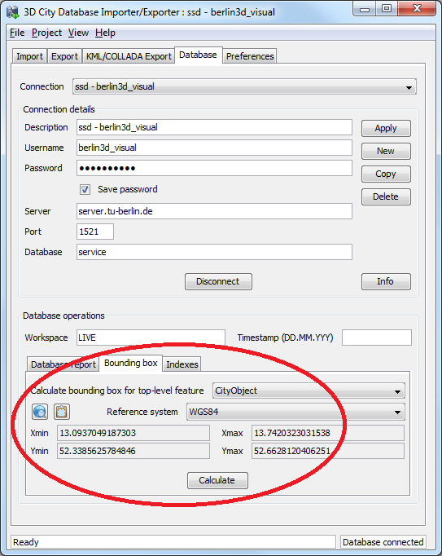
Fig. 43: Calculate maximum bounding box of a database workspace under the Database tab.
The whole maximum bounding box of all city objects of any type within the database can be now visualized by clicking on the Open Map Window button included in the Bounding box tab. A Copy to Clipboard button is included as well.
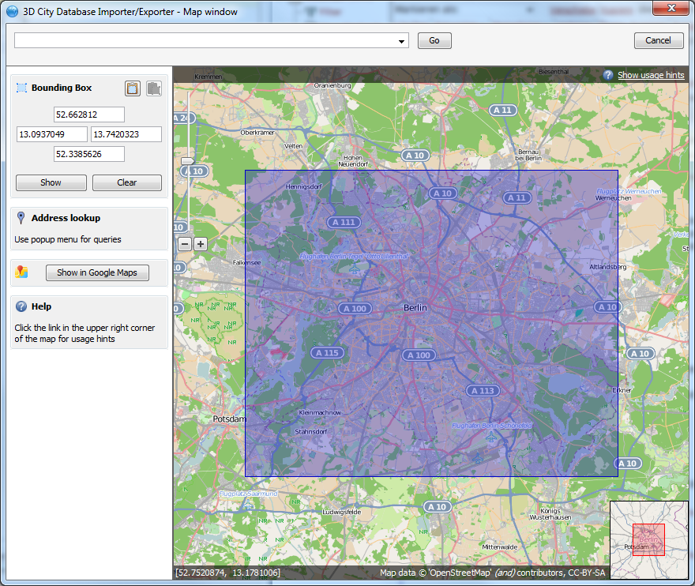
Fig. 44: Area covered by the Berlin 3D City Database. Notice the BoundingBox coordinates on the left side

- Activate and deactivate Indexes manually
Spatial and normal indexes in the currently connected database can be activated or deactivated manually. Their status can also be checked. Results will be shown in the console window. Clicking on the Activate or Deactivate buttons will only trigger the activation or deactivation process, the process itself can take a long time depending on the database fill level and it cannot be aborted by the user since this could lead to an inconsistent database state.
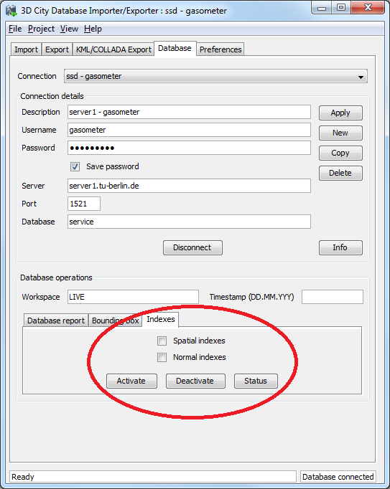
Fig. 45: Manual activation and deactivation of any index type
The user can define an Oracle workspace on which all three operations shall be executed (default is LIVE). Similar to other tabs of the Importer/Exporter, the two input fields Workspace and Timestamp are used to specify the target Oracle workspace.
In addition, a new Database preferences node has been introduced on the Preferences tab of the Importer/Exporter as shown in the Fig. 46. The Reference systems subnode facilitates the support and management of user-defined coordinate reference systems. Please refer to chapter 4.4 of these release notes for more information.

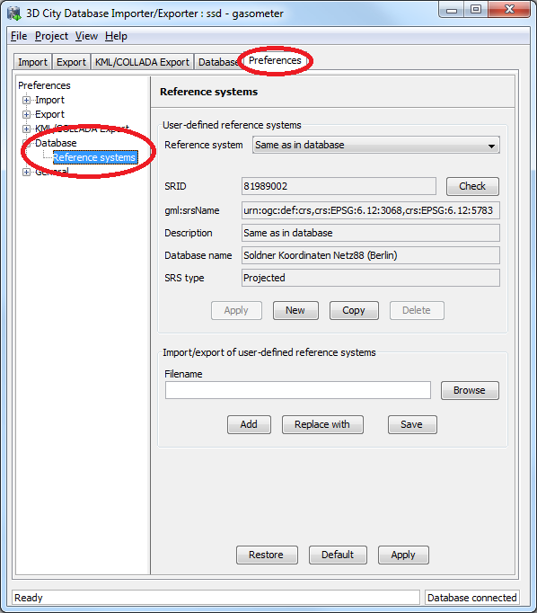
Fig. 46: New Database preferences node on the Preferences tab of the Importer/Exporter.

Proxy support in preferences
Some of the functionalities implemented in the Importer/Exporter require Internet access. This applies, for instance, to the XML validation when looking for the official xsd document or to web services called by the map window for the graphical selection of bounding boxes (OpenStreetMap service), or to web service called for the automated calculation of generic attribute GE_LoDn_zOffset in order to properly placing KML/COLLADA models onto the ground (Google elevation service), as explained in 4.3.2.4.
Most computers in corporate environments have no direct internet access but must use a proxy. The Importer/Exporter tool offers support for this configuration through the newly added Network proxies panel under Preferences - General.
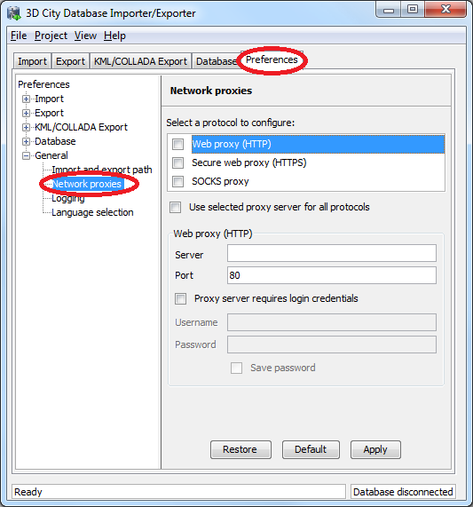
Fig. 47: New HTTP proxy preferences menu under the General node
Several proxy types can be configured separately. The Importer/Exporter Tool supports Web (HTTP), Secure web (HTTPS) and SOCKS proxies. Usually, configuring a Web proxy is enough for most tasks, like those mentioned above. However, more sophisticated use cases, like uploading cloud documents via an Importer/Exporter extension plugin (available since release 1.4.0) may require Secure web proxy (HTTPS) support. SOCKS proxy support should currently only be needed when the Importer/Exporter Tool and the 3D City Database it connects to reside in different networks.
Whenever one of the protocols to be handled by a proxy is selected the corresponding settings are filled in the fields below: Server, Port, and if the proxy requires login credentials Username and Password. It is recommended to keep the preset default Port values for each protocol (HTTP: 80; HTTPS: 443; SOCKS: 1080).
It is possible to set one single proxy for all protocols by simply selecting the checkbox under the protocol list. Just make sure the proxy supports all of them and they can all be routed through the given Port.
Proxies will only be used when the checkbox next to the protocol type is selected. Otherwise the proxy configuration data will be stored but remain inactive. When the proxy for a given protocol is actively used every outgoing connection by the Importer/Exporter which relies on this protocol will be routed through this proxy.
In case the computer running the Importer/Exporter is directly connected to the internet none of these settings are needed.

New PL/SQL functionality

PL/SQL package GEODB_DELETE
Starting from its first release, the 3D City Database has been shipped with a set of PL/SQL packages which are automatically installed during the setup procedure of the 3D City Database. These packages are required by the Importer/Exporter. The PL/SQL packages shipped with the version 2.0.6 of the 3D City Database are a mandatory dependency of the Importer/Exporter version 1.4.0 to 1.6.0. Version 2.1.0 provides additional but optional extensions to the PL/SQL packages.
The PL/SQL packages and their provided functionality can also be used to build third-party applications besides the Importer/Exporter on top of the 3D City Database. The following table enumerates the available PL/SQL packages together with a short description. All package names share the common prefix GEODB.
Package name | Description
GEODB_IDX | Provides functions to create, drop, and check both spatial and non-spatial indexes on tables of the 3D City Database.
GEODB_MATCH and  GEODB_MERGE | GEODB_MATCH implements the required functions and procedures to facilitate the matching of candidate and master buildings in the database. Based on the matching results, the GEODB_MERGE package allows for merging identified buildings.  Please check chapter 5 of the previous 3D City Database 2.0.1 documentation [1] as well as chapter 4.7 of this document for more information.
GEODB_STAT | Creates a report on the number of entities currently stored in all tables of the 3D City Database.
GEODB_UTIL | Contains utility functions.
GEODB_DELETE_BY_LINEAGE | Deletes all buildings sharing a common LINEAGE attribute (see table CITYOBJECT). Associated features and geometries will also be deleted.

With the 2.0.6 release of the 3D City Database, a new PL/SQL package called GEODB_DELETE was added to this list. It provides procedures that facilitate the deletion of single city objects in the database. Whilst the initial release of this package was restricted to the deletion of buildings, version 2.1.0 of the 3D City Database now complements the package with delete procedures for all CityGML feature types.
Since
2.1.0
The DELETE procedures do automatically take care of the many associations and dependencies between the city objects stored in the database. For example, when deleting an entry from the BUILDING table, also its associated boundary surfaces stored in THEMATIC_SURFACE as well as its addresses stored in ADDRESS are automatically removed. And, of course, also its geometry representations in all LoDs are deleted from SURFACE_GEOMETRY which again triggers the deletion of appearance information attached to these geometries. Thus, the entire building will be cleanly removed from the database.
The following overview lists the available delete procedures:
- delete_surface_geometry(pid number, clean_apps int := 0)
- delete_implicit_geometry(pid number)
- delete_external_reference(pid number)
- delete_citymodel(pid number)
- delete_appearance(pid number)
- delete_surface_data(pid number)
- delete_cityobjectgroup(pid number)
(Note: this will only delete the CityObjectGroup entry itself but not its members)
- delete_thematic_surface(pid number)
- delete_opening(pid number)
- delete_address(pid number)
- delete_building_installation(pid number)
- delete_room(pid number)
- delete_building_furniture(pid number)
- delete_building(pid number)
Since
2.1.0
- delete_city_furniture(pid number)
- delete_generic_cityobject(pid number)
- delete_land_use(pid number)
- delete_plant_cover(pid number)
- delete_solitary_veg_obj(pid number)
- delete_transport_complex(pid number)
- delete_traffic_area(pid number)
- delete_waterbnd_surface(pid number)
- delete_waterbody(pid number)
- delete_relief_feature(pid number)
- delete_relief_component(pid number)
- delete_tin_relief(pid number)
- delete_masspoint_relief(pid number)
- delete_breakline_relief(pid number)
- delete_raster_relief(pid number)
- cleanup_appearances(only_global int :=1)
- cleanup_cityobjectgroups
- cleanup_citymodels
- cleanup_implicitgeometries
- delete_cityobject(pid number)
Most of the procedures take the primary key id value (PID) of the entry to be deleted as input parameter. For delete_surface_geometry an optional second parameter CLEAN_APPS can be provided. CLEAN_APPS acts as a flag taking two values 0 (false) and 1 (true) in order to indicate whether appearance information associated with the geometry to be deleted should also be removed (default is false). The procedure cleanup_appearances removes all appearance entities that lack an associated geometry element. It also takes a flag called ONLY_GLOBAL as optional input parameter. If ONLY_GLOBAL is set to true (which is the default value), only global appearance information will be deleted. Please refer to the CityGML 1.0 specification document [2] for a comprehensive description of global and local appearance information in CityGML. The cleanup procedures cleanup_cityobjectgroups and cleanup_citymodels remove those groups and city models that do not contain members. Likewise, cleanup_implicitgeometries deletes all tuples from IMPLICILT_GEOMETRY that are not referenced by any city object any more.
Finally, delete_cityobject is a convenience procedure that can be called without having to worry about the feature type of the city object to be deleted. The delete_cityobject procedure will delegate the call to the correct delete procedure (e.g., delete_building in case a building tuple is stored at the passed PID value).
Note: The deletion of raster terrain models (RasterRelief) or associated orthophotos is not implemented since these elements will no longer be supported in the future.
The GEODB_DELETE package is meant as low-level API for the deletion of single city objects. More complex delete operations (such as “Delete only a specific LoD from a given building”, or “Delete all buildings within a given address range”) can be built on top of these low-level operations. The GEODB_DELETE_BY_LINEAGE package exemplifies this for the deletion of buildings sharing a common value in the LINEAGE column of the CITYOBJECT table. As for version 2.1.0 of the 3D City Database, also the GEODB_DELETE_BY_LINEAGE package has been complemented with procedures for all CityGML feature types besides buildings.
Since
2.1.0
In future releases, the GEODB_DELETE package will be accompanied by further low-level APIs to create and modify single objects. This will facilitate to build complex applications based on a straightforward API for the 3D City Database.

Creating Read-Only Users
In order to protect your data from unauthorized or accidental modification it can be convenient to define users having read-only access to the 3DCityDB. These users will be allowed to connect to the database and export data in both CityGML and KML/COLLADA formats, but they will be able to neither import new data into the 3DCityDB nor alter the data already stored in the tables in any way.
A dedicated script for the purpose of creating a user with read-only access to the 3DCityDB is included within the 3D City Database 2.1.0 SQL package in case the installation of this package was chosen during the setup process.
Step by step guide through the create read-only user procedure
- Open a console window.
- Change the working directory to the folder where the contents of the 3D City Database distribution package are located. In that folder, change to the UTIL/RO_USER subfolder. There is a single file in this subfolder called CREATE_RO_USER.sql.
- Open a SQLPlus connection to the database and login as admin. Any SQLPlus client software may be used.
- Execute the script CREATE_RO_USER.sql by typing
"@CREATE_RO_USER;" at the SQLPlus prompt.
Note: Make sure to change to the UTIL/RO_USER folder before running SQLPlus and executing this command.
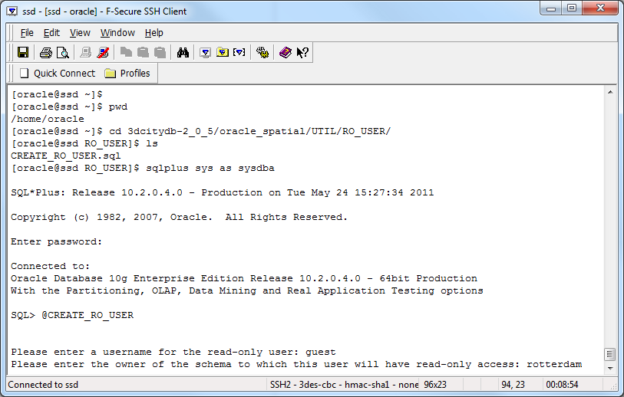
Fig. 48: Entering the data for a new read-only user.
- You will be asked to enter the name of the new read-only user to be created. This user must not exist in the database yet. Then you will be asked to enter the name of the owner of the schema (the user actually holding the city model data) to which this user shall have read-only access to. The owner of the schema must exist in the database prior to executing this script.
- The read-only user will be created and the script will exit informing you of whether it finished successfully or not.

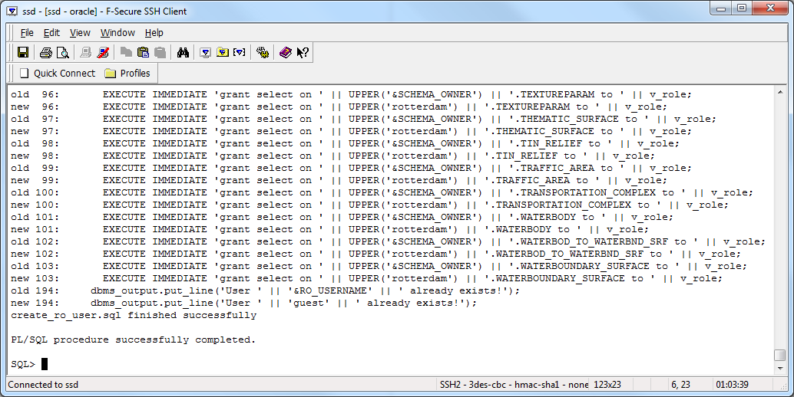
Fig. 49: Read-only user was successfully created.
- The newly created read-only user will have a default expired password "berlin3d" (without quotes). You must log in at least once with this password and change it to a new valid one for this user to be able to do some work on the 3DCityDB.
- You can now start the Import/Export Tool, define a database connection on the Database tab with this user's data, and start working (CityGML and KML/COLLADA exports only).

Note: Read-only users created with older versions of the 3DCityDB (2.0.3 or 2.0.5) will not work on Oracle databases upgraded to 2.1.0. Old read-only users must be dropped (no data will be lost in the process since read-only users hold none) and created again with the 2.1.0 version of the CREATE_RO_USER script.

Test data and template files
The Importer/Exporter is shipped with a set of sample data comprising:
- CityGML instance documents
Included are several CityGML instance documents which facilitate the testing of the CityGML import and export functionality as well as the newly introduced KML/COLLADA export capabilities.
- KML/COLLADA models
Sample KML/COLLADA models are provided which were created using the KML/COLLADA export feature. The models demonstrate many of the possibilities offered by this tool. They are ready for use and exploration in any viewer application supporting the KML and COLLADA formats, but have especially been tested for use with the earth browser Google Earth.
- KML balloon template files
One feature of the KML/COLLADA exporter is the creation of KML information balloons which are associated with the exported building objects. User-defined template files determining the layout and contents of the balloons can be fed to the Importer/Exporter. Simplified query expressions allow for filling the balloon templates with object-related information at export time. The Importer/Exporter is shipped with several example balloon templates demonstrating this feature including the recent addition of SPECIAL_KEYWORDS as explained in chapter 4.3.2.3.
- Coordinate Reference System template files
A small set of CRS templates which are provided in separate files and, thus, can be easily imported and added to the list of user-defined CRSs in the Importer/Exporter. The URN encoding of these predefined CRSs generally lacks a height reference system which has to be added before using this CRS as target reference system for CityGML exports (cf. chapter 4.4 for more information).
The contained CityGML and KML/COLLADA datasets can be found in the subfolders samples/CityGML respectively samples/KML_COLLADA within the installation folder of the Importer/Exporter. The datasets are optional and will only be copied to this location if the corresponding option is selected in the setup wizard of the Importer/Exporter during the installation procedure (by default, the sample datasets will be installed). The datasets require approx. 100MB of additional hard disk space.
The KML balloon template files are located in the subfolder templates/balloons of the installation folder. They will always be available after installation of the Importer/Exporter and may serve as a starting point for attaching information bubbles to your KML/COLLADA models. Finally, the CRS template files are organized in subfolders beneath the templates/CoordinateReferenceSystems folder located in the installation folder.
Further information and descriptions of the sample test data as well as the KML balloon template files are provided in additional README files.

Requirements
This chapter provides an overview of the minimum requirements for the 3D City Database and the Importer/Exporter tool. Please carefully review these requirements. Additional information can be found in the previous documentation of the 3D City Database version 2.0.1 (cf. [1]).
3D City Database
Since release 1.4.0 (3D City Database 2.0.6) both the Importer/Exporter and the 3DCityDB are no longer constrained to an Oracle Spatial installation, but can alternatively work on top of a PostgreSQL/PostGIS database. This is achieved by means of two separate software packages specifically coded for the database vendor they are intended to work with.
The version for Oracle of the 3D City Database requires access to a working installation of one of the following DBMSs:
- Oracle Spatial 10g R2,
- Oracle Spatial 11g R1, or
- Oracle Spatial 11g R2.
Installation of all available patches from Oracle is highly recommended for optimal stability and performance. For Oracle 10g R2, at least patch set 10.2.0.4.0 is required for using the Matching/Merging tool or the newly introduced KML/COLLADA export capabilities.
The version for PostgreSQL/PostGIS requires access to a working installation of:
- PostGIS version 2.0 or higher. PostGIS 2.0 itself requires PostgreSQL 8.4 or higher,
- For 64-bit Windows only PostgreSQL 9.0 or higher can be used.
Make sure to execute the SQL scripts v2.1.0 shipped with this release for setting up a new instance of the 3D City Database on top of your DBMS. In case an existing 3D City Database instance of previous version 2.0.5 or lower shall be upgraded, please stick to the upgrade guidelines given in chapter 6.
Importer/Exporter Tool
The Importer/Exporter tool can run on any platform providing support for Java 6. It has been successfully tested on (but is not limited to) the following operating systems: Microsoft Windows XP, Vista, 7; Apple Mac OS X 10.6; Ubuntu Linux 9, 10, 11.
Prior to the setup of the Importer/Exporter tool, the Java 6 Runtime Environment (JRE version 1.6.0_05 or higher) or Java 7 Runtime Environment (JRE version 1.7.0_03 or higher) must be installed on your system. The necessary installation package can be obtained from http://www.java.com/de/download.
The Importer/Exporter tool is shipped with a universal installer that will guide you through the steps of the setup process. A full installation of the Importer/Exporter including documentation and example CityGML files requires approx. 110 MB of hard disk space. Installing only the mandatory application files will use approx. 16 MB of hard disk space. Installation packages can be chosen during the setup process.
The Importer/Exporter and requires at least 256 MB of main memory. For the import and export of large CityGML respectively KML/COLLADA files, a minimum of 1 GB of main memory is recommended.
Please note that Importer/Exporter v1.4.0 and v1.5.0 have a mandatory dependency on the 3D City Database v2.0.6. The Importer/Exporter v1.6.0 can be used with databases of either version v2.0.6 and v2.1.0. Read more about this in the database upgrade guidelines given in the following chapter 6.

Upgrade from previous versions of the 3D City Database
Older versions of the 3D City Database (version 2.0.0 to 2.0.5) must be upgraded to version 2.0.6 / 2.1.0 in order to include the latest bug fixes and make use of the new features of the Importer/Exporter tool from release 1.4.0 upwards. The new 1.6.0 release of the Importer/Exporter can be used with both versions 2.0.6 and 2.1.0 of the 3D City Database. Thus, in case a 3D City Database instance is already running version 2.0.6, no action needs to be taken and the Importer/Exporter 1.6.0 can be used right away. In order to benefit from the latest changes to the GEODB_DELETE package, an upgrade of the 3D City Database to version 2.1.0 is required though.
Note: Versions prior to 1.5.0 of the Importer/Exporter tool will still be able to connect to the current 3D City Database 2.1.0. However, this is strongly discouraged since inconsistent values would be written in the ENVELOPE column of the CITYOBJECT table (see 3.1) at import time, and exports could also fail due to the differences in 3D CRS support offered between versions. Further unexpected behavior leading to severe database errors may also occur.
The 3D City Database 2.1.0 SQL package includes an upgrade script which will automatically perform the database upgrade. Upgrades to 2.1.0 can be carried out from any older version 2.0.0 to 2.0.6 (2.0.4 was an internal build only and has not been released for the public). No intermediate upgrades between lower versions are necessary.
Note: Upgrading does not change the existing table structure but it might affect data stored in the table CITYOBJECT. The upgrade procedure can be applied to a running database instance. However, it is recommended to first apply the upgrade in a testing environment before upgrading a production system. Furthermore, a database backup is recommended to secure all data. The latter can be easily done using the Importer/Exporter tool or by tools provided in the Oracle DBMS package.
Changes carried out in the upgrade procedure
- Uninstallation of the previous version of the GEODB PL/SQL package
The GEODB PL/SQL package is part of each release of the 3D City Database. It contains several subpackages offering a range of functionality for use with the 3D City Database. The Importer/Exporter relies on these packages and they can also be used by third-party applications. With release 1.4.0, some of these packages were reworked and new packages were added. The upgrade script will thus cleanly remove any previous version of the GEODB package.
- Installation of the GEODB PL/SQL package version 2.1.0
Since the GEODB PL/SQL package is a mandatory dependency of the Importer/Exporter version 1.4.0 and upwards, the upgrade script will install the latest version of this script in a second step.
- Renaming of indexes and constraints
Oracle allows a maximum of 30 characters for index and constraint names on tables. If these tables are version-enabled, one has to make sure that the names do not exceed a maximum of 26 characters since Oracle internally appends suffixes required for the version management. However, some of the index and constraint names of previous versions of the 3D City Database are longer than 26 characters. This causes errors in some functions of Oracle’s Workspace Manager if versioning support is enabled. To overcome this problem, the affected names are shortened in the third step of the upgrade procedure.
- Creation of additional indexes
With the release of version 2.0.2 of the 3D City Database, two additional indexes were introduced on the table APPEAR_TO_SURFACE_DATA which help to improve performance when exporting fully textured models from the database. The upgrade script makes sure to add these two indexes in a last step if they are missing.
- Update of CITYOBJECT.ENVELOPE contents
As explained in 3.1, due to compatibility issues with Oracle 11g versions, a small but significant adaption was made on the contents of the table CITYOBJECT. It affects how the BoundingBox (column ENVELOPE) is stored. The type must be switched (from rectangle to simple 3D polygon) and the amount of coordinates increases accordingly from 6 to 15. The update script makes all these changes automatically. If the geometry stored in ENVELOPE already satisfies the new storage requirements, it will not be changed by the script.
Step by step guide through the upgrade procedure
The distribution package of the 3D City Database version 2.1.0 contains all SQL scripts required for setting up a new instance of the 3D City Database or for upgrading from previous versions. The package can be downloaded as ZIP archive from the 3D City Database website at http://www.3dcitydb.net. Alternatively, the setup wizard of the Importer/Exporter offers the possibility to copy the contents of this distribution package to the installation folder of the Importer/Exporter (simply choose the corresponding installation package in the setup procedure). In the latter case, the scripts are located in the subfolder 3dcitydb.

- Open a console window.
- Change the working directory to the folder where the contents of the 3D City Database distribution package are located. In that folder, change to the UPGRADES/2.1.0 subfolder. There is a single file in this subfolder called UPGRADE_DB_TO_2_1_0.sql. This is the main SQL script controlling the upgrade procedure. Besides this script, a further subfolder called SCRIPTS is located here. The SCRIPTS folder contains additional SQL scripts which perform single steps of the upgrade procedure and are automatically executed in the background.

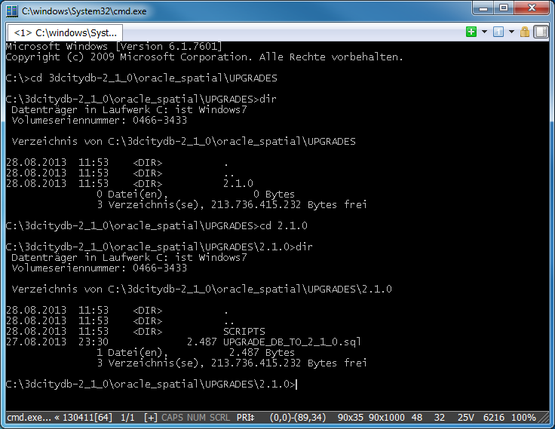
Fig. 50: Preparing for DB upgrade.
- Open an SQLPlus connection to the account of the 3D City Database which shall be upgraded. Any SQLPlus client software may be used.
- Execute the script UPGRADE_DB_TO_2_1_0.sql by typing
"@UPGRADE_DB_TO_2_1_0;" at the SQLPlus prompt. The upgrade will immediately start and automatically execute the above described upgrading steps. An upgrade protocol is printed onto the screen (see below).
Note: Make sure to change to the UPGRADES/2.1.0 folder before running SQLPlus and executing this command.
- You will be informed about conclusion of the upgrading progress by the message
"DB upgrade complete!" and the returning of the prompt.

IMPORTANT: please note that the last step in the upgrade process is a lengthy one. Altering the internal storage of the envelopes of all city objects in a large and/or versioned database may take hours. Depending on their initial state, spatial indexes may be disabled and re-enabled in the process, adding to the duration as a whole. This process MUST NOT be interrupted since it could lead to an inconsistent state. Please be patient and remember that backing up all of your data before starting any database upgrade is the commonly recommended practice.
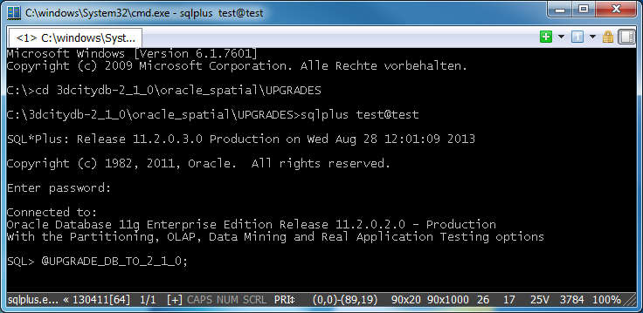
Fig. 51: Launching the upgrade script.
SQL> @UPGRADE_DB_TO_2_1_0;

MESSAGE
----------------------
Starting DB upgrade...

Starting GEODB package deletion...
Type STRARRAY deleted
Type INDEX_OBJ deleted
Type DB_INFO_TABLE deleted
Type DB_INFO_OBJ deleted
Package geodb_util deleted
Package geodb_idx deleted
Package geodb_stat deleted
Package geodb_match deleted
Package geodb_delete_by_lineage deleted
Package geodb_delete deleted
Package geodb_merge deleted
Table match_tmp_building truncated
Table match_tmp_building deleted
Table match_overlap_all deleted
Table match_overlap_relevant deleted
Table match_master_projected deleted
Table match_cand_projected deleted
Table match_collect_geom deleted
Table merge_collect_geom deleted
Table merge_container_ids truncated
Table merge_container_ids deleted
GEODB package deletion complete!

PL/SQL procedure successfully completed.

MESSAGE
---------------------------
Installing GEODB package...

Package created.
Package body created.
Package created.
Package body created.

MESSAGE
------------------------
GEODB package installed.

APPEARANCE_TO_SURFACEDAT_PK does not exist - no action required.
RELIEF_FEATURE_TO_RELIEF__PK does not exist - no action required.
CITYOBJECT_GENERICATTRIB_PK does not exist - no action required.
SOLITARY_VEGETATION_OBJEC_PK does not exist - no action required.
CITYOBJECT_GENERICATTRIB_FKX does not exist - no action required.
CITYOBJECT_GENERICATTRIB_FKX1 does not exist - no action required.
SOLITARY_VEGETAT_OBJECT_FKX1 does not exist - no action required.
SOLITARY_VEGETAT_OBJECT_FKX2 does not exist - no action required.
SOLITARY_VEGETAT_OBJECT_FKX3 does not exist - no action required.
SOLITARY_VEGETAT_OBJECT_FKX4 does not exist - no action required.
SOLITARY_VEGETAT_OBJECT_FKX5 does not exist - no action required.
SOLITARY_VEGETAT_OBJECT_FKX6 does not exist - no action required.
SOLITARY_VEGETAT_OBJECT_FKX7 does not exist - no action required.
SOLITARY_VEGETAT_OBJECT_FKX8 does not exist - no action required.
TRANSPORTATION_COMPLEX_FKX1 does not exist - no action required.
TRANSPORTATION_COMPLEX_FKX2 does not exist - no action required.
TRANSPORTATION_COMPLEX_FKX3 does not exist - no action required.
TRANSPORTATION_COMPLEX_FKX4 does not exist - no action required.
BUILDING_FURN_LOD4REFPNT_SPX does not exist - no action required.
SOL_VEGETAT_OBJ_LOD1REFPNT_SPX does not exist - no action required.
SOL_VEGETAT_OBJ_LOD2REFPNT_SPX does not exist - no action required.
SOL_VEGETAT_OBJ_LOD3REFPNT_SPX does not exist - no action required.
SOL_VEGETAT_OBJ_LOD4REFPNT_SPX does not exist - no action required.
rename_objects.sql successfully finished.

MESSAGE
-------------------------------------------------------------------------------
Creating additional indexes on APPEAR_TO_SURFACE_DATA. This may take a while...
Index APP_TO_SURF_DATA_FKX already exists.
Index APP_TO_SURF_DATA_FKX1 already exists.

MESSAGE
----------------------------------------
Updating CITYOBJECT.ENVELOPE contents...

MESSAGE
--------------------------------------------------------------------------------
Spatial indexes will be disabled and re-enabled after update. This make take a l
ong time and SHALL NOT be interrupted. Please be patient...

Disabling envelope spatial index...
updating envelope contents for all cityobjects in workspace LIVE ...
processed cityobjects in workspace LIVE = 79717; committing...
total processed cityobjects = 79717
Enabling envelope spatial index. This can take long time...
update_cityobject_envelope.sql finished successfully.

MESSAGE
-------------------------------------
CITYOBJECT.ENVELOPE contents updated.

MESSAGE
--------------------
DB upgrade complete!

Changelog
The most notable changes and bug fixes from the previous versions of both the 3D City Database and the Import/Export tool are listed in the following sections. The tables comprise the revision number and a brief description of the change or bug fix.
The software development progress can be followed at any time at http://opportunity.bv.tu-berlin.de/software. This website also provides change logs for previous releases of the 3D City Database and the Importer/Exporter tool.

Changelog for the 3D City Database
Please visit http://opportunity.bv.tu-berlin.de/software/projects/3dcitydb/repository for a complete revision overview of the 3D City Database development and access to the source code.
Notable changes between 2.0.3 to 2.1.0
Revision | Description
r117 | Complemented DELETE procedures for all CityGML feature types
r103 | Improved performance of DELETE procedures
r97 | Added script for updating cityobject envelopes in order to avoid ORA-21780 when doing spatial queries in Oracle 11g.
r90 | modified UTIL.sql to allow Importer/Exporter v1.3.x to connect to 2.0.6 databases
r78 | Reworked script for creating read-only users to properly work with version 2.0.5.
r74 | Added upgrade scripts allowing for upgrading from any previous version of the 3D City Database (2.0.3 or lower) to version 2.0.5.
r43, r62, r66 | Major rework of the matching/merging functionality; matching/merging now supports both Oracle 10g and 11g.
r39 | Added first version of GEODB_DELETE package which allows for the deletion of single objects in the database.
r33, r34 | Reworked GEODB_IDX package (providing helper procedures for spatial and non-spatial index handling) to correctly work with version-enabled tables.

Bug fixes from version 2.0.3 to 2.1.0
Revision | Description
r72 | Fixed PlanningManager compilation errors during database creation.
r38 | Fixed bugs in DELETE_BY_LINEAGE.sql which prevented the script from working on versioning enabled tables.
r37 | Fixed index/constraint names having more than 26 characters which cause problems on version-enabled tables.
r35 | Fixed bug in database report generator script (GEODB_STAT package).

Changelog for the Importer/Exporter
Please visit http://opportunity.bv.tu-berlin.de/software/projects/3dcitydb-imp-exp/repository for a complete revision overview of the 3D City Database Importer/Exporter development and access to the source code. Due to a server crash, the version control system had to be reinitialized on 2011-03-07. Changes and bug fixes before that date are not listed in the current version control system anymore, and thus are given with their date in the following tables.
Notable changes between 1.2.2 to 1.6.0
Revision / Date | Description
r851 | KML/COLLADA: COLLADA display form exports extended to LoD1 objects.
r690 | KML/COLLADA: LoD0 support added for the corresponding top-level features
r678 | KML/COLLADA: export of Relief (currently only TIN_RELIEF)
r672 | KML/COLLADA: export of Transportation
r659 | KML/COLLADA: export of LandUse
r656 | KML/COLLADA: export of WaterBody
r653 | KML/COLLADA: export of CityFurniture
r646 | KML/COLLADA: export of GenericCityObjects
r623 | KML/COLLADA: SPECIAL_KEYWORDS/CENTROID_WGS84_LAT, SPECIAL_KEYWORDS/CENTROID_WGS84_LON added to balloon handling
r613 | added support for importing/exporting xAL fragment
r597 | KML/COLLADA: intermediate commit for KML/COLLADA export of vegetation objects
r518 | KML/COLLADA: Added export of CityObjectGroups including own rendering and balloon settings
r427 | CityGML export: optionally generate unique texture filenames
r422 | Updated to citygml4j 1.0.1
r412 | Improved CityGML export of global appearances
r411 | Network proxy implementation supporting different protocols and transparent to plugin developers
r402 | KML/COLLADA: generating texture atlases with side lengths being a power of 2.
r369 | update to Oracle 11g JDBC driver version 11.2.0.3
r350 | Map dialog for bbox selection
r319 | KML/COLLADA: short summary written to the console after each export.
r313 | Optional JSON file generation. KML/COLLADA rendering preferences split into general and rendering.
r306 | Substantially improved performance for resolving of geometry XLinks.
r285 | New KML/COLLADA export option: each CityObject in a separate file.
r267 | Added Plugin API and moved to citygml4j version 1.0
r157 | Added standard editing popup menu for cut/copy/paste actions to input fields.
r11 | Introduced information about cooperation partners into GUI.
2011-03-04 | First integration of 3DCityDB scripts version 2.0.5.
2011-02-26 | Major rework of matching/merging PL/SQL functionality.
2010-12-14 | Added coordinate transformation to user-defined CRS for CityGML exports.
2010-11-09 | Support for the generation of texture atlases during KML/COLLADA exports (out-sourced in library textureAtlas.jar).
2010-10-15 | Added support and management of user-defined CRS.
2010-07-01 | Inaccessible options are automatically disabled in the GUI.
2010-06-28 | Calculation of bounding boxes for different CityGML feature types and different coordinate reference systems.
2010-06-04 | Tiling can now be applied to CityGML exports.
2010-05-20 | First integration of KML/COLLADA export functionality.

Bug fixes from version 1.2.2 to 1.6.0
Revision / Date | Description
r877 | better URL handling for import of library objects
r874 | KML/COLLADA: better fix for r859 (queries refined in order to avoid redundant geometry exports).
r867 | avoid importing of duplicate target rings of texture coordinates
r859 | KML/COLLADA: queries refined in order to avoid redundant geometry exports.
r842 | minor bugfixes for duplicate appearance targets and rgba texture images
r827 | enhanced method convertGeoPositionToPoint() to also accept an arbitrary zoom level as parameter
r825 | fixed bug with exporting boundary surfaces of buildings and rooms if the SELECT statements returns the surfaces in mixed order
r824 | avoid exporting of generic attributes with NULL value
r823 | fixed minor bug with importing/exporting of library objects associated with an ImplicitGeometry
r822 | improved stability of xAL address import when xAL fragment cannot be correctly interpreted
r818 | Bugfix for wrongly mirrored textures in TPIM algorithm.
r815 | minor fix in DBThematicSurface when exporting boundary surfaces of rooms
r802 | KML/COLLADA: fix for <heading> values in COLLADA placemarks.
r744 | KML/COLLADA: bugfix for buildings consisting of building parts modeled in different LoDs
r684 | KML/COLLADA: internal use of cityobject.id as key instead of cityobject.gmlid
r630 | KML/COLLADA: new textureAtlas library including transparency and atlas-naming fixes
r600 | KML/COLLADA: added <unknown> as theme for KML/COLLADA exports when no theme is present
r546 | KML/COLLADA: added BalloonStyle to prevent placemark names from appearing at the top of the balloons
r524 | fix for CityGML export of global appearances being associated to a surface geometry that is reused through XLinks
r523 | fix for texture coordinate strings being longer than 4000 characters
r402 | Filtering of CityGML feature types during import is now performed by citygml4j (faster)
r400 | Fixed bug when importing groups
r382 | Improved query performance on Oracle 11g
r376 | ENVELOPE now stored as planar rectangular 3D surface with 4 corner points to overcome issues with optimized 3D rectangles on Oracle 11g
r352 | Removed bug with default reference system in CLI mode
r336 | KML/COLLADA: fix for aggregating geometries for footprint or extruded when no GroundSurface is modeled. Tolerance values identical to those of matching tool.
r289 | Substantially improved performance for resolving of geometry xlinks
r205 | Fixed problems with wrong coordinate values of interior rings of polygons which are referenced by an XLink and which have to be reversed due to an OrientableSurface at the same time.
r193 | Fixed bug when importing/exporting OrientableSurface elements having textures: The order of texture coordinates was not consistent with the order of coordinate tuples in case the orientation of the surface had to be flipped.
r154 | Texture image URIs containing backslashes as path separator were not correctly interpreted on UNIX/LINUX machines.
r130, r153 | Fixed bug when importing 0 byte texture files.
r114 | Changed suffix for artificial gml:ids on gml:LinearRing elements in order to create unambiguous IDs.
r45 | Added batch counter to all CityGML importer classes in order to not exceed Oracle’s predefined maximum size for batch updates.
2011-03-01 | Adapted some SQL queries for faster execution on Oracle 11g
2011-02-18 | Fixed missing support for gml:CompositeSolid geometries when exporting Building, Room, and WaterBody features.
2011-02-08 | Minor fixes for import of deprecated CityGML TexturedSurface elements.
2011-01-07 | Database connection pool did not correctly handle failed database connections.
2011-01-07,  r42 | Fixed Oracle deadlock exceptions caused by update statements in batch mode (especially when resolving XLinks).
2010-12-14,  r26 | Fixed UTF8 issues in GUI and log console.
2010-12-06 | Solid geometries of rooms (lod4Solid property) now reference shared _BoundarySurface geometries - and not vice versa.
2010-10-21 | Fixed bugs with importing ImplicitGeometry instances.
2010-09-30 | Fixed bug when exporting appearances with different themes for the same city object.
2010-07-06 | Fixed NPE in DBExporterManager.java.
2010-07-05 | Improved memory consumption when importing large CityGML top-level features.
2010-07-01 | Added support for <pointMembers> in MassPointRelief.
2010-06-29 | Added workspace dialog to matching/merging panel.

References
[1] Kolbe, T. H.; König, G.; Nagel, C.; Stadler, A. (2009): 3D-Geo-Database for CityGML, Version 2.0.1, Documentation, April 24th.
http://opportunity.bv.tu-berlin.de/software/attachments/606/3DCityDB-Documentation-v2_0.pdf
[2] Gröger G., Kolbe, T. H., Czerwinski, A., Nagel C. (2008): OpenGIS® City Geography Markup Language (CityGML) Encoding Standard, Version 1.0.0. Open Geospatial Consortium, Doc. No. 08-007r1, August 20th.
http://portal.opengeospatial.org/files/?artifact_id=28802
[3] Wilson, T. (2008): OGC® KML, OGC® Standard Version 2.2.0. Open Geospatial Consortium, Doc. No. 07-147r2, April 14th.
http://portal.opengeospatial.org/files/?artifact_id=27810
[4] The Google Elevation API, Weblink (accessed May 2011): http://code.google.com/intl/en/apis/maps/documentation/elevation/
[5] Active Server Pages Reference, Weblink (accessed May 2011): http://msdn.microsoft.com/en-us/library/ms526064.aspx
[6] Barners, M., Finch, E. L. (2008): COLLADA - Digital Asset Schema Release 1.5.0. The Khronos Group Inc., Sony Computer Entertainment Inc, April 2008. http://www.khronos.org/files/collada_spec_1_5.pdf
[7] java - the Java application launcher, Weblink (accessed May 2011): http://download.oracle.com/javase/6/docs/technotes/tools/windows/java.html
[8] British German Academic Research Collaboration Programme on Efficient Algorithms for 2-D Rectangle packing. Weblink (accessed May 2011): http://www.csc.liv.ac.uk/~epa/surveyhtml.html
[9] Lodi A., Martello S., Vigo D. (1999): The Touching Perimeter Algorithm: Heuristic and Metaheuristic Approaches for a Class of Two-Dimensional Bin Packing Problems. In: INFORMS J on Computing: pp. 345-357.
[10] Lodi A., Martello S., Monaci M., (2002): Two-dimensional packing problems: A survey. In: European Journal of Operational Research, 141, issue 2, pp. 241-252.
[11] D. Sleator (1980): A 2.5 times optimal algorithm for packing in two dimensions. In: Information Processing Letters, Volume 10, Number 1, pp. 37–40.
[12] E.G. Coffman Jr., M.R. Garey, D.S. Johnson, R.E. Tarjan (1980): Performance bounds for level-oriented two-dimensional packing algorithms. In: SIAM Journal on Computing 9 (1980), pp. 801–826.
[13] Whiteside, A. (2009): Definition identifier URNs in OGC namespace, Version 1.3. Open Geospatial Consortium, OGC® Best Practices, Doc. No. 07-092r3, January 15th.
http://portal.opengeospatial.org/files/?artifact_id=30575
[14] Wolfram MathWorld, Weblink (accessed March 2012): http://mathworld.wolfram.com/AffineTransformation.html
[15] Murray, C. et al. (2010): Oracle ® Spatial Developer’s Guide 11g Release 2 (11.2), E11830-06, March 2010.
http://docs.oracle.com/cd/E18283_01/appdev.112/e11830.pdf

